Flower Trading Platform System

(junior) project-completed the requirements for obtaining a bachelor’s degree in informatics Engineering -
Software Engineering & Information System

Prepared By
Ahmad Raghib AL-Sayel

Supervised By
Dr. Kadan Aljouma

Jan 2025

Flower trading platform system

Project (semester) – submitted in fulfillment of the requirements for obtaining a Bachelor’s degree in Informatics Engineering - Software Engineering and Information Systems

Preparation
Ahmed Ragheb Al-Sayel

Supervision
Dr. Shadi Blidi

January 2025

Admin approval
I certify that the preparation of this project entitled Flower Trading Platform System and prepared by the student:
Ahmed Ragheb Al-Sayel
Under my supervision in the Department of Software Engineering and Information Systems at the College of Engineering, and it is part of the requirements for obtaining a bachelor’s degree in Software Engineering and Information Systems

Scientific rank: ....................
Name: ..............................
Signature:..............................
Date:.............................

Abstract Abstract

- Research topic:
Flower e-commerce is a new field that is witnessing rapid growth, due to the increasing demand for purchasing gifts and flowers online. This project aims to develop an integrated digital platform for flower trade, bringing together shop owners and customers within an easy-to-use environment, and providing a smooth, fast and secure purchasing experience.
- Objective of the research:

- Organizing the process of buying and selling flowers through an electronic platform that connects sellers and consumers in an efficient manner.
- Enabling sellers to manage their products of flowers, bouquets, and gifts, including prices, quantities, and offers.
- Facilitating the user experience by displaying flowers in an attractive way, providing delivery and payment options, and tracking orders moment by moment.
- Improving communication between customers and stores through a notification and messaging system that ensures orders arrive and are confirmed quickly.

- Extent and methodology of research:

The project includes an in-depth study of the needs of the online flower market, in terms of product management, orders, stores, and payment and delivery processes. The project relies on the analytical approach to understand the problems found in traditional methods or non-integrated applications, and then design and develop an effective digital platform based on modern software technologies and a flexible database, to ensure speed of performance and ease of expansion.

- Summary of the search process:
This project offers an integrated flower trading platform characterized by clear interfaces and attractive design, which helps sellers display their products professionally, and gives customers a convenient and fast purchasing experience. The platform contributes to raising the quality of service, supporting store owners, and organizing sales and marketing operations, which contributes to strengthening the digital flower market and expanding its services.

Table of contents

Supervisor’s Declaration…………………………………………………………………………………………………….. ii
Summary……………………………….……………………………………………………………………..iii
List of tables vii..…….……..…………………………………………………………………………………….
List of figures…….………….…….……..……………………………………………………………….. x
List of abbreviations xii……………………………………………………..……………………………………………….
Chapter One: Introduction.......................................................................................1
- Introduction ...................................................................................................2
  - The importance of the project...................................................................2
  - Project objective ................................................................................................2
  - Project overview................................................................................2
- The problem ..................................................................................................3
- Research objective ..............................................................................................3
- The proposed system.............................................................................................3
- Organization of the report..............................................................................................3
- Conclusion.................................................................................................3
Chapter Two: Basic concepts and reference study ................................................................4
1-Introduction ....................................................................................................5
2- Basic concepts of the flower trading platform ................................................................................5
3- Reference study ................................................................................................6
4- The importance of the research ..............................................................................................6
- Potential benefits of the system ................................................................................7
- Challenges and successes faced by flower trading platforms ....................................................8
- Common problems faced by customers and management ............................................................10
- Needs and expectations of customers, vendors and management...................................................12
- Gathering requirements ................................................................................................14
9-1 Similar systems...................................................................................14
9-2 Questionnaire............................................................................................16
- The proposed system ................................................................................................19
- Conclusion ...............................................................................................20
Chapter Three: Analytical study of the proposed system ..............................................................21
1-Introduction ..................................................................................................22
2- Feasibility study ................................................................................................22
3-Gantt chart.............................................................................................26
4- Project schedule .................................................................................. 27
- Requirements document for the proposed system ................................................................................28
- SRS Document ............................................................................................29
- Table of actors and use cases .......................................................................34
9-About the Unified Modeling Language (UML) .......................................................................35
10-Use case diagram.................................................35
10.1 Use case diagram ................................................................................36
11- Textual description of use cases ................................................................................38
11.1 Administrator use cases ..............................................................................38
11.2 Farm use cases ..............................................................................52
12- Activity diagrams ................................................................................................58
13- Sequence diagram ................................................................................................64
14- ER Diagram ........................................................................................67
15- List of preliminary tests ................................................................................. 68
16- Developing a requirements tracking matrix ................................................................................70
17- System architecture .............................................................................................72
Chapter Four: Design study of the proposed system ............................................................. 73
- Introduction ................................................................................................74
- Class Diagram ................................................................................76
2-1 Description of the row plan ................................................................................75
2-2 Class plan...................................................................................75
2-3 The basis that was adopted in the class plan...................................................77
3- Design models at the physical level ........................................................................ 78
Chapter Five: Practical Application ................................................................................80
- Introduction................................................................................................. 81
- Tools used ................................................................................ 81
- Techniques used................................................................................... 82
- Mini models of the implementation process ............................................................................. 84
Chapter Five: Conclusions and future prospects ................................................................87
- Introduction................................................................................................. 88
- Future prospects ....................................................................................... 88
References ................................................................................................................89

List of Tables
- Table 3.1 Project timeline ........................................................................................ 27
- Table 3.3 Actors and use cases ..............................................................................34
- Table 3.4 Login process ................................................................................................39
- Table 3.5 Administrators’ management process ................................................................................39
- Table 3.6 The process of adding administrators ................................................................................ 40
- Table 3.7 The process of deleting administrators ................................................................................40
- Table 3.8 Process for modifying officials.................................................................................41
- Table 3.9 Process of modifying administrators’ powers ........................................................................41
- Table 3.10 Farmer management process.................................................................................42
- Table 3.11 Farmer deletion process.................................................................................42
- Table 3.12 Farms modification process ................................................................................................43
- Table 3.13 The process of adding farms.................................................................................43
- Table 3.14 Farmer Presentation Process ................................................................................44
- Table 3.15 The process of deactivating farms ..............................................................................44
- Table 3.16 Customer management process.......................................................................................45
- Table 3.17 Customer Presentation............................................................................................45
- Table 3.18 Adding a customer .............................................................................................46
- Table 3.19 Deleting a customer .............................................................................................46
- Table 3.20 Modifying a client ..................................................................................................47
- Table 3.21 Deactivating a client ................................................................................................47
- Table 3.22 Managing roles and powers ................................................................................48
- Table 3.23 Presentation of roles............................................................................................48
- Table 3.24 Display of powers.................................................................................49
- Table 3.25 Adding a role ..............................................................................................49
- Table 3.26 Add Delete Role .......................................................................................50
- Table 3.27 Adjusting the role ................................................................................................50
- Table 3.28 Assigning authority to a role...................................................................................51
- Table 3.29 Withdrawing authority from a role.................................................................................51
- Table 3.30 Login............................................................................................53
- Table 3.31 Product Management............................................................................................53
- Table 3.32 Delete a product ................................................................................................54
- Table 3.33 Modifying a product ..............................................................................................54
- Table 3.34 Deactivating a product............................................................................................55
- Table 3.35 Adding a product............................................................................................55
- Table 3.36 Managing requests.............................................................................................56
- Table 3.37 View requests ................................................................................................56
- Table 3.38 Acceptance of the application...................................................................................................57
- Table 3.39 Rejection of the application ................................................................................................57
- Table 3.40 Portfolio Management............................................................................................58
- Table 3.41 List of preliminary tests ................................................................................68
- Table 3.42 Requirements Traceability Matrix ................................................................................70

List of figures

- Figure 2.1 BloomNation ................................................................................ 14
- Figure 2.2 Çiçeksepet.......................................................................................15
- Figure 2.3 Questionnaire results ..............................................................................................16
- Figure 3.1 Gantt chart ........................................................................................26
- Figure 3.2 High level use case diagram ..............................................................36
- Figure 3.3 Low level use case diagram.................................................................37
- Figure 3.4 Admin use case diagram ................................................................................38
- Figure 3.5 Farmer use case diagram ................................................................................52
- Figure 3.6 Login activity diagram ................................................................................58
- Figure 3.7 Order Management Activity Diagram ................................................................................58
- Figure 3.8 Product Management Activity Diagram............................................................................59
- Figure 3.9 Add Product activity diagram ................................................................................59
- Figure 3.10 Account Data Completion Activity Diagram ..................................................................59
- Figure 3.11 Diagram of the Flower Search activity ........................................................................60
- Figure 3.12 Activity diagram of deactivating an account.................................................................60
- Figure 3.13 Account creation activity diagram............................................................................61
- Figure 3.14 Farmer Login Activity Diagram................................................................61
- Figure 3.15 Product Modification Activity Diagram .............................................................................62
- Figure 3.16 Delete product activity diagram.............................................................................62
- Figure 3.17 View All Requests activity diagram...................................................62
- Figure 3.18 Request Presentation Activity Diagram ........................................................................63
- Figure 3.19 Application Approval Activity Diagram ...................................................................63
- Figure 3.20 Login Sequence Diagram ...................................................................64
- Figure 3.21 Farmer management sequence diagram ................................................................64
- Figure 3.22 Sequence diagram for adding farms ........................................................................65
- Figure 3.23 Farmer deletion sequence diagram .............................................................................65
- Figure 3.24 Farmer data modification sequence diagram ................................................................66
- Figure 3.25 ERD diagram ........................................................................................67
- Figure 3.26 MVC Diagram........................................................................................72
- Figure 4.1 Class Diagram ................................................................76
- Figure 5.1 Login page ................................................................................84
- Figure 5.2 Website home page ................................................................................84
- Figure 5.3 Add Administrator page................................................................................85
- Figure 5.4 Administrators table page ................................................................................85
- Figure 5.5 Farmer home page.................................................................................86

List of abbreviations

HTML | Hypertext Markup Language
CSS | Cascading Style Sheets
PHP | Personal Home Pages
SQL | Structure Query Language
UML | Unified Modeling Language
ERD | Entity Relationship Diagram
SRS(IEEE) | Software Requirement Specification  (Institute of Electrical and Electronics Engineer)
MVC | Model ,View , Controller

Chapter one
Introduction
Chapter One: Introduction
1.Introduction:
1.1 The importance of the project:
In light of the rapid digital transformation and individuals increasingly relying on electronic platforms to meet their daily needs, online flower trade has become an area of clear growth. This project aims to develop an integrated electronic platform for flower trade, which helps store owners and customers communicate easily, and provides a smooth and organized purchasing experience.
The importance of the project lies in several basic aspects, the most prominent of which are:
- Improved store management: The platform allows flower shop owners to manage their products, offers, inventory, and prices in an accurate and easy way.
- Facilitating the purchasing process: Customers can browse the types of flowers and bouquets in an attractive and organized manner, while providing multiple options for payment and delivery.
- Enhancing communication: The platform provides a direct channel between the seller and the customer to confirm orders and address inquiries.
- Reducing operational costs: By switching to a digital platform, the need for traditional marketing or manual sales management is reduced.
- Raising the level of organization: Orders, delivery status, and payment are tracked electronically, which reduces errors and saves time.
Overall, the project offers a modern digital solution that contributes to improving the experience of buying and selling flowers, and supports store owners in organizing their businesses and expanding their customer base.
1.2 Project objectives:
- Facilitating and accelerating the process of purchasing flowers through an easy-to-use electronic platform.
- Enabling store owners to manage their products, orders, and inventory effectively.
- Reduce errors resulting from manual purchasing processes or traditional communication.
- Raise customer satisfaction by providing attractive interfaces and flexible delivery and payment options.
- Providing a comprehensive and organized database for products, stores, and orders.
- Ensuring the security and integrity of data stored for long periods.
- Improving the user experience through easy access to information and updating it at any time.
- Supporting store owners with statistics and reports that help improve performance and increase sales.

3.1 Project overview:
This project aims to develop an integrated electronic platform for flower trade, which includes managing store data, products, orders, payment processes, and delivery services, in addition to managing customer accounts. The platform simplifies buying and selling processes, provides an organized digital environment that enhances service quality and supports the growth of the online flower market.
2. The problem:
Many flower shops and small shops have obvious difficulties in managing orders and coordinating sales, especially when relying on traditional methods such as telephone communication or random messages. This leads to confusion in registering orders, delays in preparing packages, and difficulty in keeping track of the status of each order. All of these factors negatively affect the efficiency of store operations, and hinder the achievement of a smooth and enjoyable purchasing experience for customers.
3. Research objective:
This research aims to improve the buying and selling experience between customers and flower shop owners, and facilitate the processes of registering orders, organizing products, and managing inventory, ensuring a higher level of service and increasing work efficiency. The research also seeks to develop a dynamic environment that allows the merchant to manage his store electronically, and for the user to access products easily and quickly.
4. The proposed system:
The project proposes to develop an integrated digital platform for flower trade, which can be used by shop owners and customers online from anywhere.
This system addresses problems found in traditional methods and provides effective solutions including:
- Managing store and product data (flower types, bouquets, prices, quantities).
- Organizing orders automatically and displaying their status (in preparation - delivered...).
- Manage payment and delivery in an organized manner linked to each order.
5. Organizing the report:
The project report will be organized according to the following chapters:
- Introduction
- Problem with the current system
- Reference study
- Proposed system
- System design
- System implementation
- System testing and evaluation
- Conclusions and recommendations
- References
6. Conclusion:
Given what was discussed in the previous paragraphs, it becomes clear how important it is to have a digital platform specialized in flower trade, and the great benefit it provides in terms of organization, ease of use, and improving communication between customers and stores. Therefore, this report will present the steps, methods and processes that the team will take to reach the final product with the highest quality and efficiency.

Chapter Two
Basic concepts and reference study

Chapter Two - Basic concepts and reference study
1-Introduction:
This chapter is an introduction to our project, as we highlight the basic concepts associated with flower commerce platforms, in addition to providing a background study that reviews the current systems used in the field of flower e-commerce and how they can be developed and improved.
This project aims to develop an integrated digital platform that meets the needs of flower shop owners and customers, and contributes to facilitating and improving daily operations such
as: managing products, adding and updating floral bouquets, booking orders, tracking delivery, and organizing the store’s work.
The benchmark study in this chapter includes an analysis of some similar platforms operating in the flower business, identifying their strengths and weaknesses, and how the proposed project can provide a more advanced experience.
At the end of this chapter, we will discuss the importance of the project and the extent to which it contributes to improving workflow within stores and increasing customer satisfaction through effective management of orders, inventory, and delivery operations.
2- Basic concepts of the flower trading platform:
1. Information system:
It is an integrated organization that combines data, people, and technology, with the aim of providing accurate information that supports decision-making, such as managing orders, products, and sales statistics within the platform.
2. Flower trading platform:
It is an electronic environment that allows flower shop owners to display their products of flowers, bouquets and gifts, and enables customers to order them easily online, while supporting payment and delivery options.
3. Flower shop management system:
It is an information system that aims to facilitate the daily operations of stores, such as adding products, updating inventory, managing orders, following up on delivery, and processing payments.
4. Database:
An organized collection of data on products, prices, customers, orders, and inventory, stored in a coherent manner that allows quick and easy access to it when needed.
5. Digital system:
It refers to the use of software and digital technologies to organize buying and selling processes, instead of traditional manual methods, which increases work efficiency and reduces errors.

6. Information technology:
It is the use of hardware, software, and networks to manage store data and online business operations. In the context of the platform, it is used to organize products and orders and facilitate communication between the store and the customer.
7. Digital records of the order:
It is an electronic file that contains all the details of the order, including the product type, price, customer name, delivery location, and order status, which makes it easier for the merchant to accurately follow up on order processing.

- Reference study for flower trading platforms:
With the rapid development of e-commerce, there is an urgent need for effective digital solutions to manage flower sales and delivery operations. In light of the increasing reliance on electronic platforms for purchasing gifts and flowers, the need has emerged for a digital system that facilitates communication between stores and customers and improves the quality of service.
Flower trading platforms aim to achieve effective communication between the store and the customer, and organize daily procedures such as adding products, registering orders, following up on delivery, and managing payment electronically.
With the presence of many platforms such as Souq (Souq Flowers, Floward, BloomNation), it has become important to analyze these systems to know their features:
- Strengths: Attractive interfaces, ease of ordering, multiple delivery options.
- Weaknesses: Lack of customization for small stores, limitations in inventory management, poor reporting and analytics.
By leveraging these studies, our project seeks to offer a more integrated platform, supporting the merchant with advanced features and organizing the customer experience from the beginning of the order until it is received.

- The importance of research
The importance of this system stems from its ability to:
1. Improving the quality of services: by displaying products in a professional manner and with accurate details that help the customer make an appropriate decision.
2. Facilitating access to services: The customer can easily order flowers or bouquets through the application or platform.
3. Save time and effort: for both parties, by reducing manual communication and organizing requests electronically.
4. Enhancing interaction: The store can send updates about the order status or new offers directly to the customer.
5. Support business decision-making: through reports showing the best-selling products, peak periods, and remaining inventory.

This system contributes to raising the efficiency of work within the flower shop, improving the relationship between the merchant and the customer, and increasing the level of professionalism in providing service.

- Potential benefits of a flower business management platform:

Below are the most prominent benefits that the flower trade management platform can achieve by implementing this digital system:

- Improving administrative efficiency
- Automating processes: such as managing orders, registering customers, organizing purchases and sales, and issuing invoices.
- Performance monitoring: Enable management to monitor sellers' performance, daily sales, and the level of demand for products.
- Improve customer experience
- Ease of access: enabling customers to browse types of flowers, arrange bouquets, and place orders electronically at any time.
- Notifications and alerts: Sending notifications of order status, delivery date, or available offers.
- Customer Profile: Contains history of previous orders, addresses, and flower preferences.
- Increase revenue
- Expanding the customer base: through electronic selling and reaching a larger segment of users.
- Additional services: such as express delivery, customized event layouts, or monthly subscriptions.
- Smart offers and marketing: Offering personalized discounts and promotions based on customer behavior.
- Improve communication
- Interactive channels: Direct communication between the platform and customers for inquiries or customization of orders.
- Customer ratings and opinions: Collect feedback to improve the quality of products and services.
- Manage resources efficiently
- Organizing orders and deliveries: Scheduling processing and delivery operations in an efficient manner.
- Inventory management: Track quantities of flowers, tools, ensure product availability and reduce waste.
- Data analysis and decision support
- Detailed reports: about sales, most in-demand products, and peak times.
- Statistical dashboards: showing market trends and customer purchasing behavior.
- Enhance security
- Data Protection: Securing customer data and payment processes using modern technologies.
- Access permissions: Determine the permissions of users (manager, seller, delivery employee) according to job role.
- Integration with other systems
- Electronic payment systems, delivery companies, and accounting systems to facilitate operational processes.

- Regulatory compliance
- Compliance with laws related to e-commerce and customer data protection.
- Environmental sustainability
- Reducing waste: by managing inventory efficiently and reducing spoilage.
- Reducing paper: relying on electronic invoices and digital transactions.
- Scalability and development
- Adding future features: such as artificial intelligence to suggest packages or expanding to new branches and stores.

- Challenges and successes faced by flower trading platforms when adopting electronic systems
Many flower shops and platforms around the world have witnessed a significant shift towards digitalization, by adopting electronic systems to manage sales, orders, inventory, and delivery operations. Despite the opportunities for development and improvement that this transformation brings, it was accompanied by a set of challenges, in addition to achieving clear successes. Studying these experiences is an important step for any project aiming to create a modern online platform for flower trade.
Challenges:
- Initial cost
Development costs: The cost of designing a custom flower business platform can be high, especially if it includes features such as customization, delivery, and electronic payment.
Training: Using the system requires training of personnel (vendors, management staff, and delivery teams), which initially poses a financial and time burden.
2. Adapt to change
Resistance to change: Some workers or store owners may be reluctant to move from traditional methods to digital systems.
Adaptation: Users need time to understand how to manage orders and inventory through the new system and integrate it into their daily workflow.
3. Technical problems
Software errors: Technical problems may arise during the operation of the platform, such as order errors or electronic payment malfunctions.
Integration with devices: Some platforms may face difficulties in linking with delivery companies or electronic payment gateways.
4. Data security
Privacy Protection: The platform requires securing customers' personal information and payment data.
Cyber Threats: The risks of hacking and cyber attacks remain a challenge that requires the implementation of advanced security solutions.

5. Maintenance and updates
Continuous maintenance: The platform needs continuous updates to ensure performance and respond to market requirements.
Additional costs: Technical support costs may be a burden on small or emerging projects.

Successes:
1. Improving operational efficiency
Process automation: Electronic systems have accelerated ordering, billing, and delivery tracking processes.
Better inventory management: It is now possible to track flower quantities and avoid shortages or spoilage.
- Improve customer experience
Ease of use: Customers can easily browse flowers, choose bouquets, and place orders online.
Personalized service: The platforms provided the possibility of saving customer preferences and history of previous orders.
- Increase sales and revenues
Expanding the customer base: Digital platforms have helped in reaching new customers outside the traditional geographical scope.
Additional services: such as express delivery, organizing packages for events, and seasonal offers.
- Improve decision making
Analytical reports: The systems provided accurate reports on sales, most in-demand products, and peak times.
Marketing Insights: Data analysis has helped improve marketing strategies and promotions.
- Enhance security
Transaction protection: Systems contributed to securing payment processes and reducing errors or fraud.
Power management: The ability to specify user powers according to role (manager, seller, delivery employee).
- Systems integration
Effective integration: Many platforms have succeeded in linking management systems with electronic payment gateways, delivery companies, and accounting systems, which helped speed up work and reduce operational errors.

- Common problems faced by customers and management that a flower e-commerce platform can solve
Traditional flower shops and shops face a number of problems that affect the quality of service provided and the efficiency of operational management. Adopting an integrated electronic platform for managing flower trade contributes significantly to addressing these challenges and improving workflow. Below is a presentation of the most prominent problems that both customers and management suffer from, along with the solutions provided by the electronic platform.
Problems faced by customers:
1. Difficulty in ordering flowers and organizing appointments
Problem: C
ustomers have difficulty knowing the types of flowers available, arranging bouquets, or placing orders, in addition to the need to contact the store by phone or visit the store in person.
Soluti
on: The online platform allows customers to browse flowers, choose bouquets, and set the delivery date and time easily online.
2. Inability to track order status
Problem:
Customers lack a clear way to know the status of their orders (processing, shipped, delivered).
Solution
: The platform provides an order tracking system that displays the order status in real time with automatic notifications of each update.
3. Unclear or complicated payment procedures
Problem: C
ustomers may have difficulty knowing the final price of the order, or the available payment methods.
The sol
ution: The platform offers clear and secure electronic payment gateways, with detailed invoices and multiple payment options (cards, electronic transfer, payment upon receipt).
4. Poor communication or lack of information
Problem: C
ustomers suffer from a lack of information regarding offers, delivery times, or exchange and return policies.
Solution:
The platform provides a notification system and instant messages for announcements, offers, and order updates, in addition to a direct communication channel with support.

Problems faced by management:
1. Manage orders and inventory manually
Problem: Relying on traditional methods leads to errors in order recording or loss of inventory data.
Solution: The platform manages orders and inventory digitally, automatically updating quantities and organizing data accurately.

2. Difficulty organizing delivery and resources
Problem: Poor organization of deliveries or scheduling conflicts lead to delayed orders and customer dissatisfaction.
Solution: The platform provides smart scheduling tools to organize orders, delivery teams, and delivery times very efficiently.
3. Poor data analysis and decision making
Problem: It is difficult for management to track sales volume, most in-demand products, or evaluate overall performance without a digital system.
Solution: The platform provides analytical reports and graphs that help management make decisions based on accurate data.
4. Ineffective communication with employees or customers
Problem: Delay or poor coordination occurs between management, vendors, and delivery teams.
Solution: The platform has internal communication tools and instant alerts that facilitate coordination and improve response speed.
5. Complex financial management
Problem: Management has difficulty keeping track of invoices, payments, and daily or monthly profits.
Solution: The platform provides an integrated financial management system that includes electronic invoicing, tracking revenues and expenses, and preparing financial reports.

Examples of additional solutions:
Integration with delivery companies: to link orders directly to shipping services and track them.
Multiple language support: to expand the customer base from different regions and nationalities.
Automatic reminders: To send notifications about order status, delivery dates, or seasonal offers.

Conclusion
The e-flower trade management platform contributes to addressing most of the challenges facing customers and management, by improving the user experience, increasing operational efficiency, and providing better control of orders, inventory, and data. This leads to increased customer satisfaction, improved sales, and enhanced competitiveness of the enterprise in the flower trade market.

8. Needs and expectations of customers, vendors, and management of the electronic system in the flower trading platform
When developing an electronic platform for managing a flower business, it becomes necessary to understand the needs and expectations of different categories of users, namely: customers, vendors (or florists), and management. The requirements of each category differ, but meeting them together contributes to the success of the platform and achieving an integrated digital experience. Below is a breakdown of the needs and expectations of each category:
Customer needs and expectations
Customer needs:
- Ease of access: A platform available via the web and smartphone applications that allows quick access to accounts and orders.
- Ordering flowers: The ability to browse types of flowers, choose bouquets, specify quantities, and customize the order according to the occasion.
- Order management: View previous order history, delivery addresses, and purchasing preferences.
- Communication with the store: There are direct communication channels to inquire about orders or customize packages.
- Notifications and alerts: Receive notifications of order status, delivery dates, and seasonal offers.
- Electronic payment: Supporting safe and smooth electronic payment methods, with invoices clearly displayed.
Customer expectations:
- Easy and intuitive user interface: simple and organized design suitable for different age groups.
- Accurate and up-to-date information: such as flower availability, prices, and delivery policies.
- Personalized experience: Suggest packages or offers based on customer purchase history and preferences.
- Quick technical support: The ability to communicate with the support team to solve technical or operational problems.
2. Sellers' needs and expectations
Sellers' needs:
- Daily order management: View incoming orders and organize them by priority and delivery time.
- Access order details: View customer requirements, package type, and special notes.
- Time management: Organizing the time for preparing packages and coordinating them in accordance with the delivery schedule.
- Inventory management: Following up on the availability of flowers and tools for coordination.
Sellers expectations:
- Easy and quick to use system: clear interface that does not require complex training.
- Flexibility in modification: the ability to update the request status or modify its details when needed.
- Operational reports: View the number of completed requests, late ones, and the percentage of punctuality.
3. Management needs and expectations
Management needs:
- Centralized data management: A unified system for storing customer, order, and vendor data.
- Billing and Payments: Financial tools for invoicing, tracking payments, and analyzing revenue.
- Resource management: organizing work teams, inventory, and deliveries.
- Performance analysis: administrative and financial reports on sales, customer satisfaction, and operating efficiency.
- Data Security: A secure system that ensures the protection of customer data and financial transactions.
Management expectations:
- Comprehensive control panel: A central administrative interface that makes it easy to monitor all platform operations.
- Increase operational efficiency: Automate processes to reduce manual work and reduce errors.
- Scalability: The ability to develop the platform and add new features in the future.
- Reduce costs: improve resource management and reduce operational waste.
Conclusion
By meeting the needs and expectations of customers, vendors, and management, the e-flower trade management platform contributes to providing an integrated digital experience that enhances user satisfaction, raises operational efficiency, and supports data-driven management decision-making, which helps achieve sustainable growth and a strong competitive advantage in the flower trade market.

9- Gathering requirements:
  - Similar systems:
  - BloomNation:
Link: https://www.bloomnation.com/
Pros:
- One-stop Flower Market: Connects customers with a wide range of local flower designers in one place.
- Show real photos of layouts: Designers upload their real photos instead of staged photos, which enhances customer confidence.
- Ease of customization: It offers a wide choice of packages according to occasions and music.
Cons:
- Marketplace commission: The platform takes a commission on each order (like Etsy), which may reduce the profit margin for the seller.
- Limited vendor control: The designer may find that interface customization and order management options are limited compared to standalone platforms.
- Local Market Focus: A designer's success depends on how expanded the client base is in his city/region.
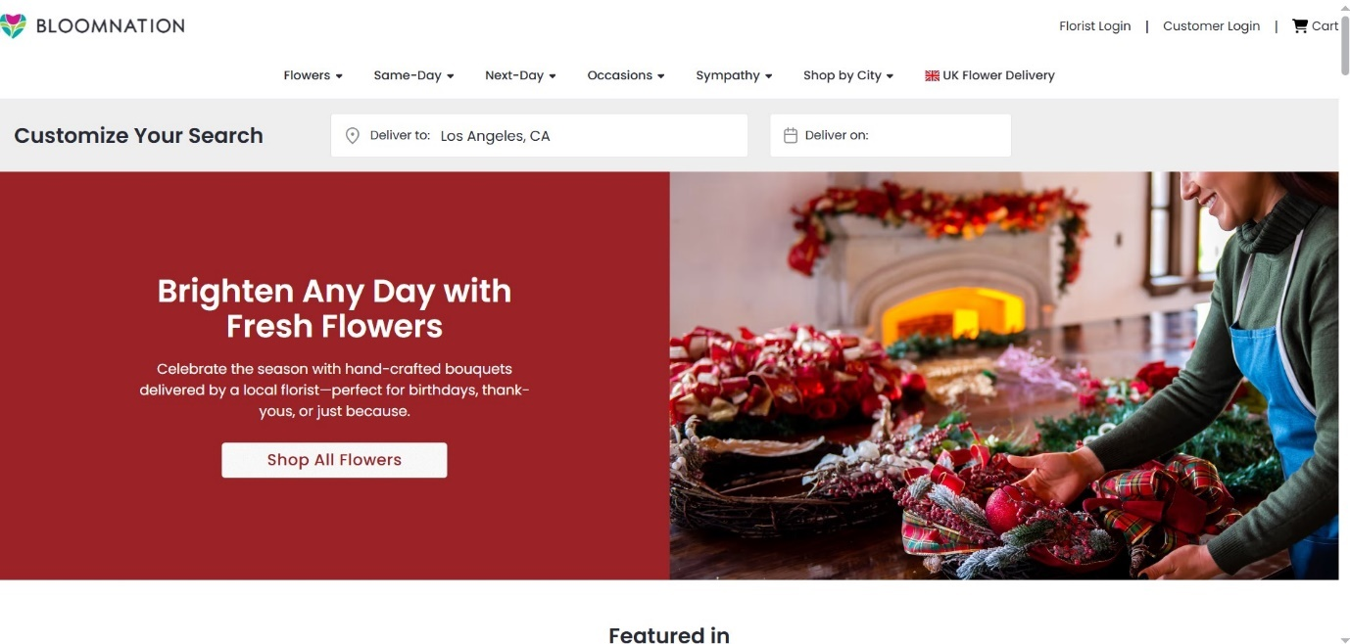

BloomNation Figure 2.1

  - Çiçeksepet
Link: https://www.ciceksepeti.com/

Pros:
- High volume in the regional market: Flowers and gifts trading platform with a wide reach in Türkiye.
- Product variety: includes flowers, gifts and home delivery.
- Powerful interface and applications: Supports a convenient user experience for online ordering and delivery.

Cons:
- Delivery costs: May be high for cities far from distribution centers



Çiçeksepet Figure 2.2

9-2-Questionnaire: [9]
Given the importance of digital transformation in managing commercial activities, especially in the flower trade sector, and with the widespread use of the Internet as a primary means of selling and communicating with customers, a field questionnaire was prepared with the aim of studying the reality of using electronic means in the flower trade, and assessing the need to implement an integrated electronic platform for managing the flower trade.
This questionnaire was directed to a sample of customers, vendors/florists, and administrative employees, with the aim of collecting realistic data that contributes to identifying the current gaps in traditional work mechanisms, and clarifying the functional and technical priorities that must be present in the proposed system.
The most important objectives of the questionnaire:
- Understanding customers' needs for electronic services, such as browsing flowers, ordering bouquets, tracking orders, and electronic payment.
- Evaluate the level of satisfaction of customers, vendors, and management with traditional ways of working or current systems, if any.
- Determine the operational and administrative priorities that must be present in the flower e-commerce platform.
- Improving communication and interaction between customers, vendors, and management.
- Enabling management to make informed decisions based on realistic data extracted from the questionnaire results.
🔹 Survey results and data analysis
In order to assess the need for an electronic platform for managing the flower trade, a questionnaire was distributed to a sample of customers, vendors, and administrative employees. The questionnaire included a set of questions that measured the level of awareness of using electronic systems, the degree of satisfaction with current work methods, and their expectations from the proposed platform.
The results of the analysis showed that there is a clear need for an integrated electronic system that contributes to improving the user experience, increasing operational efficiency, and organizing sales and delivery operations more effectively.
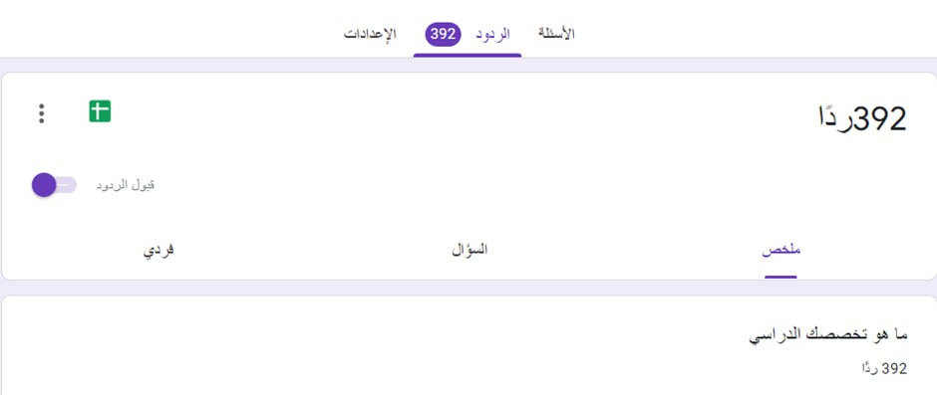
Survey results:
Figure 2.3 Questionnaire results.
Survey questions for flower e-commerce management platform:

1. Do you think that having an integrated electronic platform enhances the customer and employee experience?
Yes: 85%
No: 10%
Not sure: 5%
Analysis: The results indicate that the majority of participants realize the importance of the electronic platform in improving customer and employee experience and facilitating sales and communication processes.
2. What are the most attractive features of the flower business management platform?
Product display and management (types of flowers and bouquets) 35%
Effectively manage orders and deliveries25%
Immediate communication with customers 20%
Order tracking and status 10%
Sales analytical reports 10%
Analysis: Participants focus on the importance of product display and order management, demonstrating the need to improve basic day-to-day operations in the flower business.
3. What is the most important impact of the electronic platform on the quality of service provided?
Improving service quality and customer satisfaction: 40%
Increased operational efficiency: 30%
Reduced errors in orders and delivery: 20%
Enhancing communication between the store and customers: 10%
Analysis: Improving service quality is the most important goal from the participants' point of view, followed by improving operational efficiency and reducing errors.
4. Does the electronic platform increase customer satisfaction and loyalty?
Yes: 75%
No: 15%
Not sure: 10%
Analysis: The results show a clear conviction that the electronic platform contributes to building customer loyalty and improving their purchasing experience.

5. What are the current challenges in managing the flower business using traditional methods?
Poor integration between orders and inventory: 25%
Difficulty organizing orders and deliveries: 20%
Lack of updated product information: 20%
Lack of sales analysis tools: 20%
Complexity of administrative procedures: 15%
Analysis: The results highlight the fundamental weaknesses of traditional management methods, which are aspects that the proposed electronic system should target.
6. Do you prefer to use digital services such as online ordering and delivery tracking?
Yes: 60%
No: 20%
Not sure: 20%
Analysis: The results indicate good acceptance of digital transformation, which reflects users’ willingness to use online platforms to purchase flowers.
7. Do you think providing how-to content on flower care and events is useful?
Yes: 80%
No: 10%
Not sure: 10%
Analysis: Participants show great interest in informative content, which supports the idea of including an educational section within the platform.
8. Suggestions to improve flower trade services
Improved packaging quality and formatting: 25%
Conduction acceleration: 20%
Diversifying packages according to occasions: 20%
Training employees on customer service: 20%
Providing offers and discounts to regular customers: 15%
Analysis: These results reflect users' desire for a comprehensive improvement of the service, including operational and marketing aspects, not just the technical aspect.

Conclusion:
The survey results show that there is a real and growing demand for an integrated electronic platform for flower trade management, as the majority of answers focused on improving product display, facilitating ordering, and organizing delivery. A clear acceptance of digital services and interest in communication and instructive content was also observed, which supports the decision to develop this platform from both the technical and commercial aspects, and contributes to raising the level of customer satisfaction and enhancing the competitiveness of the project.

- Proposed system:
The proposed system is an integrated electronic information system for managing online flower trade, aiming to organize and facilitate the processes of selling and marketing flowers and related products, and improving the administrative and commercial workflow with
in the platform. This system is designed to serve three main parties: customers, sellers/stores, and management, through flexible and easy user interfaces that ensure a smooth user experience and high efficiency in managing operations.
Basic system functions:
For customers: browse the types of flowers and gift bouquets available with price details, place purchase orders online and choose the appropriate payment method, follow up on the status of orders and delivery times, receive notifications about order status, offers, and deliveries.
For sellers: Manage available products and packages, add or modify prices, follow up on incoming orders and prepare them for delivery, manage seasonal offers and discounts, and view store sales reports.
For management: supervising stores and sellers registered on the platform, managing orders, payments and deliveries, following up on inventory and product availability, creating analytical reports on the platform’s performance and sales.
The most important features of the system:
1- Integrated management of products and orders: The syst
em allows displaying and organizing flowers and bouquets in a coordinated manner, while tracking orders from the moment they are created until they are delivered.
2- Ease of purchasing and electronic payment: P
roviding a smooth purchasing experience through simple interfaces and multiple payment options that suit different users.
3- Improving communication between the parties of the pla
tform: connecting customers, sellers, and delivery services through a unified system that ensures speed of response and accuracy of implementation.
4- Track order and delivery status: En
able customers to follow their orders step by step, which enhances confidence and transparency in the service.
5- Comprehensive analytical re
ports: Providing reports related to the number of orders, best-selling products, customer satisfaction level, and daily or monthly revenues.

- Conclusion
The proposed electronic system for managing online flower trade is an effective solution to keep pace with the digital transformation in the e-commerce sector, as it contributes to improving the quality of service provided to customers, and raising the efficiency of administrative and commercial processes within the platform.
With the increasing demand for electronic purchasing and competition in the flower market, adopting such an integrated system contributes to:
- Reducing effort and time in managing orders and traditional sales.
- Enhancing customer satisfaction through speed of implementation and accuracy of delivery.
- Enabling management and vendors to make more accurate business decisions based on data and analytical reports.

Chapter Three
Analytical study of the proposed system
Chapter Three: The analytical stage of the proposed system
- Introduction:
In this chapter, the analytical phase of a flower e-commerce platform management system project will be reviewed, through a feasibility study, requirements gathering, requirements document preparation, and system modeling using appropriate tools to design an effective platform that meets the needs of the main users: customers, vendors/stores, and management.
- Feasibility study:
The economic feasibility of implementing a flower e-commerce platform management system is an essential process to determine whether the project brings financial and organizational benefits that justify investment in it. The study includes an evaluation of the expected costs and benefits with a comprehensive analysis of risks and returns. The following are the most important elements of the feasibility study:
1. Implementation cost:
The total cost of developing the system includes:
Software development (product browsing interface, order management, store management, electronic payment gateway, offers and discounts system).
Cost of human resources (programmers, designers, system analysts).
Technical equipment and supplies (servers, computers, secure hosting system).
Promotional costs to launch the platform in the market and increase the customer base.
2. Expected revenues:
The system is expected to contribute to:
Increasing the number of customers by facilitating the online browsing and purchasing process.
Improving customer experience through order tracking and on-time delivery, which enhances customer loyalty.
Enabling sellers to better manage their stores and increase sales volume.
The possibility of expanding the platform to include new stores or seasonal products, and increasing revenues from commissions or subscriptions.
3. Maintenance and operation cost:
Include:
Host the system on a secure cloud or local server.
Regular maintenance of the system and fixing any software malfunctions.
Periodic updates to add new features or improve user experience.
Technical support for vendors and customers to solve any technical issues.
4. Analysis of expected benefits:
Reduce time wasted on managing orders and inventory by automating processes.
Improving the quality of customer service by closely following up on each request and providing continuous notifications.
Increase the efficiency of store management and digital resources, and reduce errors in orders or inventory.
Providing clear reports that help management make accurate marketing and business decisions (such as best-selling products, peak times, customer ratings).
5. Cost-Benefit Analysis:
By comparing costs against expected benefits, it is estimated that the system will contribute to increasing sales and revenues by at least 30% during the first six months, while improving customer satisfaction and reducing administrative errors, leading to stable platform operations and an increased customer base.
6. Risk assessment:
Resistance by some vendors or customers to adopt the electronic system.
Service interruption due to internet outage or server problems.
Poor training of support staff or vendors to use the system properly.
The constant need to update the system and add new features to comply with market needs and digital legislation.

Result:
The feasibility study indicates that developing an integrated flower e-commerce platform is an effective and profitable investment in the medium and long term, whether in terms of increasing sales volume, improving customer experience, or raising the efficiency of managing the platform’s commercial and administrative operations.

Economic feasibility analysis of the electronic flower trade platform project: (Please note that these numbers are fictitious and are for illustrative purposes only and may vary depending on actual conditions and economic fluctuations)
1. Implementation cost:
- System development and design (interface for browsing and purchasing products, managing orders, payment gateway, managing offers and discounts): 12,310,000,000 SYP.
- Annual marketing costs (advertising, social media campaigns, cooperation with stores and vendors): 1,500,000 SYP.
- Total costs of the project in the first year: 11,500,000 SYP.
2. Expected revenues:
- For sellers or commission on sales: 50,000 SYP. For one store
- The goal: to attract 100 stores in the first year.
- Expected annual revenues: 100 x 50,000 x 12 = 60,000,000 SYP.
3. Maintenance and operation cost:
- Hosting and operating costs (servers, domain): 2,000,000 SYP.
- Annual updates and technical support costs: 1,500,000 SYP.
- Total operating and maintenance costs in the first year: 3,500,000 SYP.
4. Benefits Analysis:
- Facilitating browsing and purchasing products online, which increases customer satisfaction and reduces pressure on traditional sales teams.
- Improve communication between the platform, customers and sellers through automatic notifications and order tracking.
- Providing an accurate database for each store and order, which helps in analyzing sales and making accurate marketing decisions.
- Increasing the number of customers frequenting the platform thanks to the ease of using the application and speed of service.
- Increasing the efficiency of time and resource management for vendors and management, while reducing errors in orders and shipping.
5. Cost-Benefit Analysis:
Expected net return in the first year: Revenues - (implementation cost + operation and maintenance) \= 60,000,000 - (11,500,000 + 3,500,000) \= 45,000,000 SYP.
6. Risk assessment:
- Difficulty convincing local sellers to join the platform at first.
- Weak technical infrastructure for some users or Internet outages.
- The ongoing need to provide training and technical support to new vendors and customers.
- The emergence of competing platforms with cheaper prices or different services may affect the platform's market share.
- The project relies on monthly subscriptions or commission, which may lead to revenue fluctuations if some vendors withdraw.

This analysis indicates that the integrated flower e-commerce platform has strong economic viability, with a high net return in the first year and the potential for future expansion to include new stores or seasonal products. It is recommended to begin implementation with a focused marketing plan and dedicated technical support to ensure that sellers and customers are attracted and continue to use the platform.

3-Gantt chart:

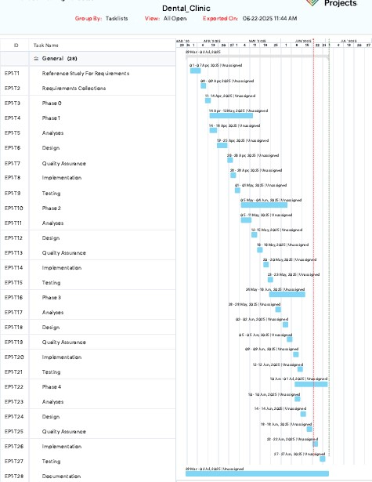
Gantt chart Figure 3.1

A Gantt chart is a project management tool used to visually represent tasks and timelines for projects. It was invented by American engineer Henry Gantt in the early 1900s, and is one of the most widely used tools in project management.

4- Project schedule:

Mission | The beginning | The end | Description | Tools | implemented before
Gather requirements | 01/09/2025 | 15/09/2025 | Definition of project requirements | Reference study and comparison with similar sites | Ahmed
System analysis | 16/09/2025 | 31/09/2025 | Analyze functional and non-functional requirements using UML diagrams | Draw.io | Ahmed
Design | 01/10/2025 | 20/10/2025 | System, interface and database design | Interface design using html  Css ,js ,bootstr,  And programming via  Php and laravel framework | Ahmed
Implementation | 21/10/2025 | 23/11/2025 | Writing code | Visual studio  Mysql | Ahmed
Testing | 24/11/2025 | 10/12/2025 | Testing the efficiency of the completed parts of the project | Unit testing | Ahmed
Report | 11/12/2025 | 4/01/2025 | Writing the report | Word program | Ahmed

Project schedule Table 3.1

6- Requirements document for the proposed system
6-1 Methodology followed:
Stages of the iterative development methodology:
- Basic Planning (Inception): In this stage, the project objectives and main requirements are determined. The project scope and general timeline are defined.

- Iteration: This stage includes developing a small part of the project. This phase can last for a certain period of time, and is usually short, such as two weeks to a month.

3. Evaluation: After the iteration is completed, the results are evaluated and examined to ensure that the set goals have been achieved. Feedback is collected from customers or users and planning is returned based on this feedback.

4. Planning for the Next Iteration: Based on the evaluation and feedback, it is determined what needs to be developed in the next iteration and plans and schedules are adjusted accordingly.

5. Execution: More features or parts are developed and built in this iteration according to the specified plan.

6. Continuous Evaluation and Improvement: The evaluation and improvement process is repeated repeatedly in each iteration. Past observations and experiences are used to improve processes and ensure that project requirements are best met.

These stages are repeated until the final goal of the project is achieved. An iterative development methodology allows better adaptation to changes in project requirements, ensures the most satisfactory results and reduces significant risks of failure by dividing the project into small, effectively manageable parts.

7.SRS Document(IEEE 830)
It is a document that specifies the requirements for the software to be developed. This document contains a detailed description of the functions and features
The software must include them, in addition to functional and non-functional requirements and other considerations related to the system.
SRS contains the following components:
- Project name: Flower e-commerce platform system
- Introduction:
This project aims to develop an integrated electronic platform for flower trade that allows users to easily browse and purchase flowers and their products online, while providing effective tools for managing orders, electronic payment, and delivery. The platform
also aims to support flower shop owners in displaying their products, managing inventory, and tracking sales, in addition to enabling management to monitor overall performance and make decisions based on accurate data, which contributes to improving the user experience and enhancing the efficiency of commercial operations in the flower market.
3- System description:
- The system allows improving and facilitating the management of flower trade electronically through a unified platform that brings together customers, sellers, and management.
- It contributes to organizing product, order, and customer data in an accurate digital way instead of traditional methods.
- It facilitates the process of browsing flowers, ordering, paying, and communicating between customers and flower shops.
- It helps improve customers' purchasing experience through an easy-to-use interface, clear product images, and flexible delivery options.
- The system provides a safe environment for conducting financial transactions and protecting user and seller data in accordance with approved security standards.
System requirements:
- Actors:
- Administrator
- Visitor
- Farmer
- Client

- Functional requirements:

- Visitor job requirements:
He logs into the system
Create an account via email
Complete the account information
Browse Products (View Categories – Sorting Types)
Search for flowers (by name - by color)

- Farmer functional requirements:
He logs into the system via email
Product management (delete a product - edit a product - deactivate a product - add a product)
Request management (accept request - reject request)
View orders (pending - finished - ongoing)
Portfolio management (displaying earnings from the wallet balance - displaying the withdrawable balance - displaying earnings for each product
- Submit a profit withdrawal request - View profit withdrawal requests - View the profit withdrawal request history)

- Customer functional requirements:
He logs into the system via email
Show products
Add a product to favorites
Remove a product from favorites
View favorites
View product details (reviews - pictures - price)
Order management (cancel orders - view previous and ongoing orders)
Cart management (add a product to the cart - delete a product from the cart - modify the quantity)
Complete the order

- Admin job requirements:
He logs into the system
Administrators management (add - delete - modify data - modify permissions)
Farmer management (view - add - delete - modify - deactivate)
Customer management (view - add - delete - modify - deactivate)
Manage roles and permissions (view roles - view permissions - add a role - delete a role - modify a role -
Assigning authority to a role - withdrawing authority from a role)

3-Non-functional requirements:
Performance:
The system must be able to handle the required number of users without any degradation in performance
Security:
The system must be secure from unauthorized access
This requirement may be achieved in the system by:
Ease of use:
The interfaces between the system and the system manager are easy to use and clear, which helps the user to deal with the system
well
This requirement has been achieved in our system by designing user interfaces that are easy and comfortable to use
Maintainability:
The system should be easy to maintain and update
The requirement is achieved in the system by using the MVC framework. It helps in separating the components of the system from...
Some of them help in facilitating the application maintenance process
Availability:
The degree of operation of a system or component and its accessibility when needed to use it

- Performance requirements
1- Response time:
The response time of website pages should be less than 2 seconds to achieve a smooth and fast user experience
Content should load quickly and efficiently to avoid delaying the content to appear to users
2- Use of resources:
You must optimize database usage and perform efficient queries to reduce the time it takes to retrieve data
Improve the performance of reading and writing data
3- Endurance:
The site must handle a large number of users and requests during peak periods
Performance and site endurance must be improved when dealing with a large volume of data
4-Application response:
The application must have fast performance in carrying out calculations and operations related to money and inventory
The performance and speed of searching and browsing should be improved
5-Scalability:
The application must be scalable to accommodate increasing user volume and future requirements
The application architecture should be extensible and additional modules and components can be added easily without
Impact on overall performance
5-Design requirements
1-User interface:
The user interface must be simple and easy to use to enable system actors to navigate and interact easily
The user interface must be compatible with the various devices and screens used, including computers
Desktops, tablets and smartphones

2-Page design and structural system:
Page design must be structurally neat and organized to enable users to find the content
Easily
Pages must be designed in a way that allows quick and flexible navigation between the different sections of the system

3-Database design:
The database must be reliable and secure to protect sensitive data and prevent data loss or damage

4-System security:
A system must be designed with high security standards to protect user data and ensure the confidentiality of personal information
Anti-hacking mechanisms must be implemented and the system protected from cyber attacks

6-Testing requirements
1-Functional test:
Customer registration and creation of new accounts should be tested to validate the process
2- Compatibility test:
System compatibility should be tested with popular web browsers and different operating systems
System responsiveness and responsive design should be tested on the various devices and screens used
- Security test:
Users must be tested to protect data and ensure confidentiality of personal information
The protection and security mechanism must be tested to prevent unauthorized access
4-Performance test:
The system's performance must be comprehensively tested to ensure its rapid and effective response
The system must be tested to withstand high loads

5-Stability test:
The stability of the system should be tested when it is operated for long periods of time and under different conditions
Fault handling and data recovery should be tested in case of system failure

7- Project restrictions
1.Technology limitations:
There may be technical limitations related to programming requirements or tools and techniques used in developing the system. We may have
Certain limitations on the scope of technical support, computers and Internet connection.
2. Time constraints:
We may encounter time constraints regarding scheduling and project implementation. We must take into account the specific delivery schedule
project and achieve the set goals in a timely manner.
3. Resource constraints:
We may have limitations on the financial, human and material resources available for the project. We must control the use of resources appropriately
Effective and achieve project objectives with the best use of available resources.
- Security and privacy restrictions:
We may encounter security and privacy limitations in the system. We must follow data security and privacy protection practices
users and provide a safe environment
5. Compatibility and responsiveness limitations:
We may encounter limitations regarding system compatibility with various devices, browsers and operating systems. We must ensure compatibility
System with a variety of devices and provide fast response and appropriate user experience.

8- Table of actors and use cases:
The subject | Use cases
Administrator | He logs into the system  Administrators management (add - delete - modify data - modify permissions)  Farmer management (view - add - delete - modify - deactivate)  Customer management (view - add - delete - modify - deactivate)  Manage roles and permissions (view roles - view permissions - add a role - delete a role - modify a role -  Assigning authority to a role - withdrawing authority from a role)
Visitor | He logs into the system  Create an account via email  Complete the account information  Browse Products (View Categories – Sorting Types)  Search for flowers (by name - by color)
Farmer | He logs into the system via email  Product management (delete a product - edit a product - deactivate a product - add a product)  Request management (accept request - reject request)  View orders (pending - finished - ongoing)  Portfolio management (displaying earnings from the wallet balance - displaying the withdrawable balance - displaying earnings for each product  - Submit a profit withdrawal request - View profit withdrawal requests - View the profit withdrawal request history)
Client | He logs into the system via email  Show products  Add a product to favorites  Remove a product from favorites  View favorites  View product details (reviews - pictures - price)  Order management (cancel orders - view previous and ongoing orders)  Cart management (add a product to the cart - delete a product from the cart - modify the quantity)  Complete the order

Table of actors and use cases 3.3 Table

9-About the Unified Modeling Language (UML):
It is a graphical modeling language that provides a syntax for the main elements of software systems, called artifacts, and is moving towards the UML.
Unified Modeling Language is one of the most common methodologies for coding software processes. It was published by the most famous international methodologists and found wide acceptance among those interested in building software regardless of their methodologies.
The Unified Modeling Language provides a simplified symbolic means of expressing various software business models, through which it is easy for stakeholders, including analysts, designers, programmers, and even users, to communicate with each other and pass information in a unified and concise stereotypical form that eliminates the need for the usual linguistic description.
They are like building plans that engineers and architects exchange, or electrical and electronic circuit diagrams that any being in this field can understand and deal with.
Each UML diagram is designed so that developers and consumers can view the software system from different perspectives and with different degrees of abstraction. The following diagrams illustrate this.

10-Use Case Diagram:
A use case is a description of the system's behavior from the user's point of view. For the system developer, it is a useful technique for all system requirements from the user's point of view. The actor symbol is used. The actor here is an entity that initiates the use case, and this entity could be another person or system.
The use case diagram displays the relationship between the Actor and the Use Case, for the main components of this diagram, which are the use case and the Actor. From this it is clear that this diagram shows the main components in the system.

10.1 Use case diagram
The following figure shows the relationships between those involved in the system:
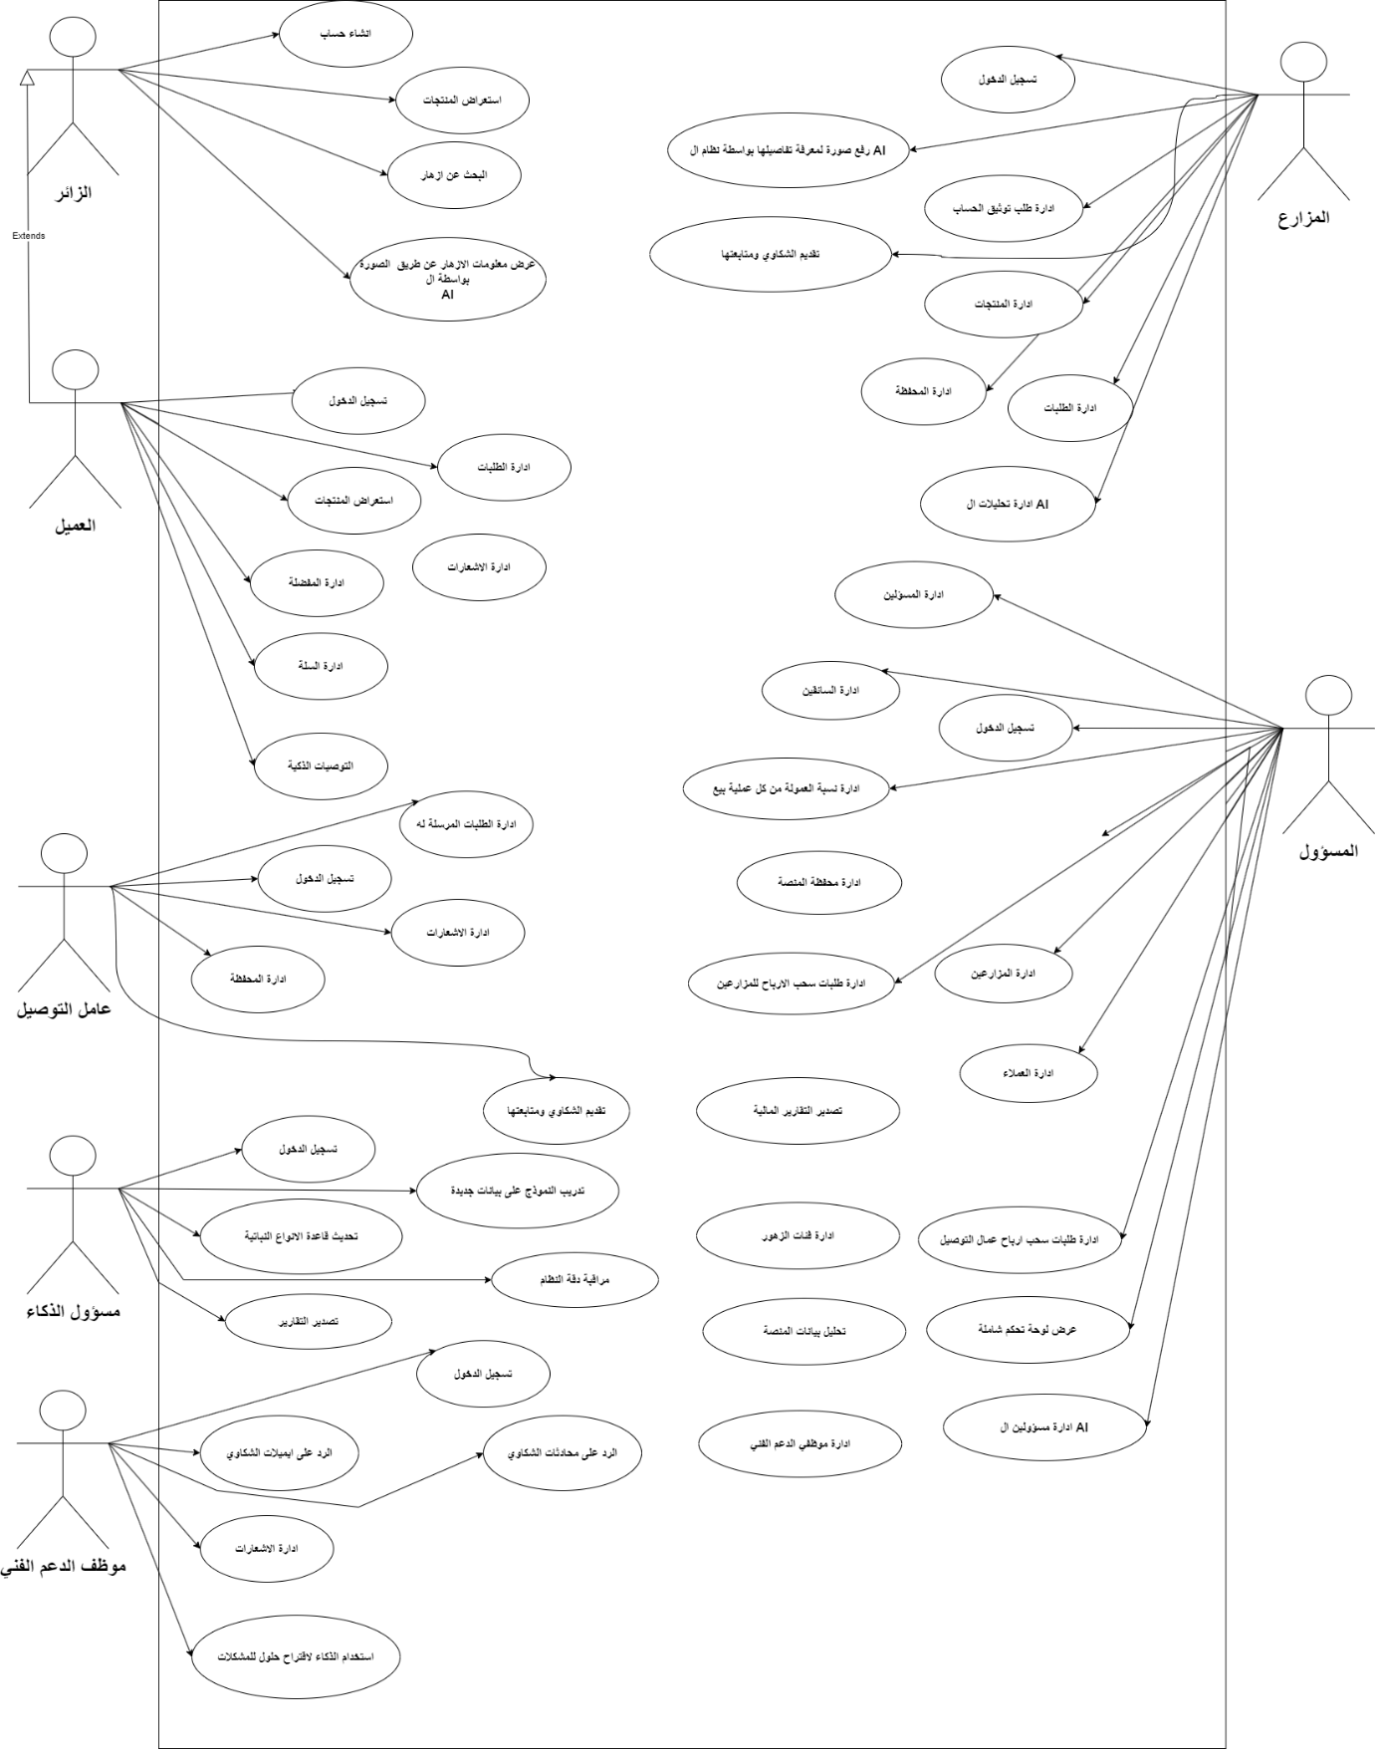

High level use case diagram Figure 3.2

10.1 Use case diagram
The following figure shows the relationships between the functional requirements we collected and those involved in the system:
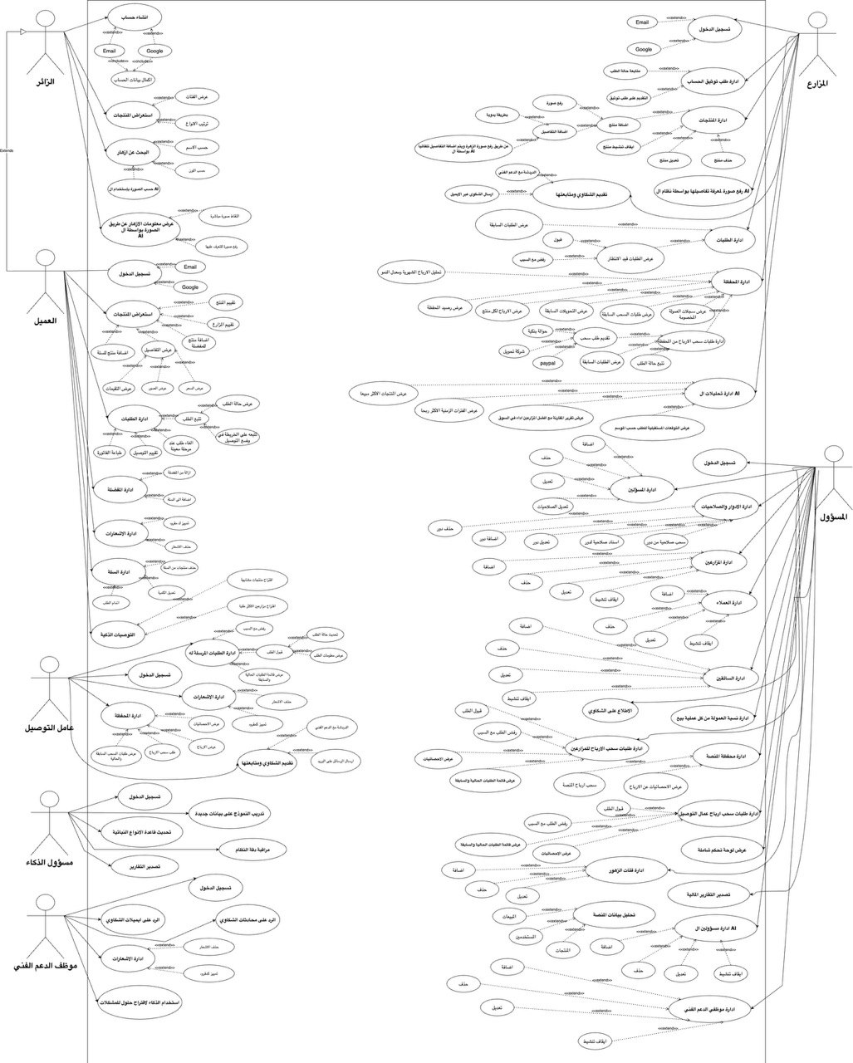

Low level use case diagram Figure 3.3

11-Textual description of use cases:
Use case documentation
11-1 Textual description of administrator use cases:

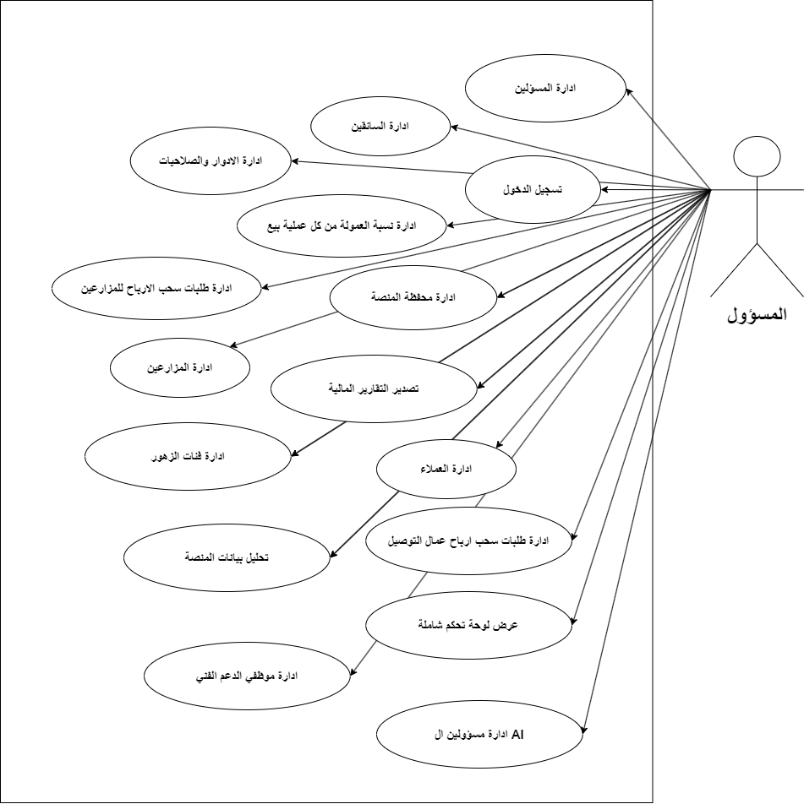
Admin use cases Figure 3.4

Use case number | Req-01
Use case | Login
Brief description | The administrator enters his email and password and then logs in
The actors | Administrator
Previous conditions | The user enters the system
Subsequent terms | Log in to the account successfully
Main flow | 1-The user enters the site  2-Click on Log In  3-He enters his personal data  4-The system verifies the entered data  5-The system redirects the user to his own page
Alternative flows | If the user does not enter the data correctly, the system sends an error message to correct the error
Login process table Table 3.4

Use case number | Req-02
Use case | Administrative management
Brief description | The manager manages the officials
The actors | Administrator
Previous conditions | The administrator must be logged in
Subsequent terms | The official must enter the correct information about the officials
Main flow | 1-The administrator enters the site  2-Click on Manage Administrators  3-The system displays a list of available options  4-The administrator chooses to add, delete, or modify administrators
Alternative flows | There is no

Administrators management process table Table3. 5

Use case number | Req-03
Use case | Add administrators
Brief description | Administrator adds administrators
The actors | Administrator
Previous conditions | The administrator must be logged in
Subsequent terms | The administrator must add correct information about the officials and be able to add them
Main flow | 1-The administrator enters the site  2-Click on Manage Administrators  3-Enter the administrator’s data  4-The system verifies the entered data and sends a message confirming the addition process
Alternative flows | If the administrator does not enter the data correctly, the system sends an error message to correct the error
Table 3.6 of the process of adding administrators

Use case number | Req-04
Use case | Delete administrators
Brief description | The administrator deletes the administrators
The actors | Administrator
Previous conditions | The administrator must be logged in  The administrator must have previously added the administrator
Subsequent terms | The administrator can delete the administrator
Main flow | 1-The administrator enters the site  2-Click on Manage Administrators  3-The system displays a list of available options  4-The manager chooses the admin view  5-The system displays a list of administrators available in the system  6-The administrator selects the official he wants to delete and clicks Delete  7-The system displays a message confirming the deletion process
Alternative flows | If the manager does not enter the data correctly, the system sends an error message to correct the error
Table 3.7. Administrators deletion process table

Use case number | Req-05
Use case | Modify administrator data
Brief description | The administrator modifies the information of administrators in the system
The actors | Administrator
Previous conditions | The manager must be logged in  The manager must have previously added the administrator
Subsequent terms | The manager can modify the administrator’s details in the system
Main flow | 1-The manager enters the site  2-Click on Manage Administrators  3-The system displays a list of available options  4-The manager chooses to display administrators  5-The system displays a list of administrators available in the system  6-The manager selects the official whose data he wants to modify and clicks Edit  7-The system displays a message confirming the modification process
Alternative flows | If the manager does not modify the data correctly, the system sends an error message to correct the error
Administrators Modification Process Table 3.8 Table

Use case number | 06Req-
Use case | Modifying the powers of administrators
Brief description | The manager modifies the powers and roles he gave to the administrator
The actors | Administrator
Previous conditions | The administrator must be logged into the system
Subsequent terms | The administrator can modify the powers granted to any other administrator
Main flow | 1-The administrator clicks on the official whose powers he wants to modify  2-The system shows a list of system administrators  3-The administrator can modify the permissions he wants  4-The system displays a message confirming the modification of permissions
Alternative flows | There is no
Table 3.9 of the process of modifying administrator privileges

Use case number | Req-07
Use case | Farmer management
12qbrief description | The administrator can manage the farmers in the system
The actors | Administrator
Previous conditions | The administrator must be logged in
Subsequent terms | Administrator can add, delete, modify and view farmers in the system
Main flow | 1-The administrator enters the site  2-Click on Farmer Management  3-The system displays a list of available options  4-The administrator chooses the option he wants
Alternative flows | There is no
Farmer management process table Table 3.10

Use case number | Req-08
Use case | Delete farms
Brief description | The administrator deletes farms
The actors | Administrator
Previous conditions | The administrator must be logged in  The administrator must have added farms previously
Subsequent terms | The administrator can delete farms
Main flow | 1-The administrator enters the site  2-Click on Manage Farms  3-The system displays a list of available options  4-The official chooses the farmers’ offer  5-The system shows a list of farmers available in the system  6-The administrator selects the farmer he wants to delete and clicks Delete  7-The system displays a message confirming the deletion process
Alternative flows | There is no
Table 3.11. Farm deletion process table

Use case number | Req-09
Use case | Modify farms
Brief description | The administrator modifies the farmer's information in the system
The actors | Administrator
Previous conditions | The administrator must be logged in  The administrator must have added farms previously
Subsequent terms | The administrator can modify farm details in the system
Main flow | 1-The administrator enters the site  2-He puts pressure on farmers’ management  3-The system displays a list of available options  4-The official chooses the farmers’ offer  5-The system shows a list of farmers available in the system  6-The administrator selects the farmer whose data he wants to modify, writes the new data, and clicks Edit  7-The system displays a message confirming the modification process
Alternative flows | If the manager does not modify the data correctly, the system sends an error message to correct the error
Farmer modification process table 3.12 Table

Use case number | 10Req-
Use case | Add farms
Brief description | The administrator adds farms to the system
The actors | Administrator
Previous conditions | The administrator must be logged in
Subsequent terms | The official must enter the correct information about the farmer and his management
Main flow | 1-The administrator enters the site  2-He puts pressure on farmers’ management  3-The system displays a list of available options  4-The administrator chooses Add, writes the farmer’s data, and clicks Add  5-The system displays a message about the success of adding farms
Alternative flows | If the administrator does not enter the data correctly, the system sends an error message to correct the error
Table 3.13. Adding farms process

Use case number | Req-11
Use case | Farmers show
Brief description | The administrator displays the farmers in the system
The actors | Administrator
Previous conditions | The administrator must be logged in
Subsequent terms | That the administrator can view the farmers and manage them
Main flow | 1-The official puts pressure on the farmers’ management  2-The system displays a list of available options  3-The official clicks on the farmers’ offer  4-The system shows a list of farmers available in the system
Alternative flows | There is no
Farmer Presentation Process Table 3.14

Use case number | Req-12
Use case | Deactivate farms
Brief description | The administrator deactivates farms in the system
The actors | Administrator
Previous conditions | The administrator must be logged into the system  The administrator must have added farms previously
Subsequent terms | The manager can stop the activation and work of a specific farmer
Main flow | 1-The administrator enters the site  2-He puts pressure on farmers’ management  3-The system displays a list of available options  4-The official chooses the farmers’ offer  5-The system shows a list of farmers available in the system  6-The administrator selects the farmer who wants to stop his work and clicks Deactivate  7-The system displays a message confirming the shutdown process
Alternative flows | There is none
Table 3.15 Farm deactivation process table

Use case number | Req-13
Use case | Customer management
Brief description | The administrator can manage clients in the system
The actors | Administrator
Previous conditions | The administrator must be logged in
Subsequent terms | Administrator can add, delete, modify and view customers in the system
Main flow | 1-The administrator enters the site  2-Click on Customer Management  3-The system displays a list of available options  4-The administrator chooses the option he wants
Alternative flows | There is no
Customer management process tableTable 3.16

Use case number | Req-14
Use case | Customer show
Brief description | The administrator displays the clients in the system
The actors | Administrator
Previous conditions | The administrator must be logged in
Subsequent terms | The administrator can view and manage customers
Main flow | 1-The administrator clicks on Customer Management  2-The system displays a list of available options  3-The administrator clicks on Customer View  4-The system shows a list of clients available in the system
Alternative flows | There is no
Customer Presentation Management TableTable 3.17

Use case number | Req-15
Use case | Add a client
Brief description | The administrator adds a client to the system
The actors | Administrator
Previous conditions | The administrator must be logged in
Subsequent terms | The administrator must enter the correct information about the client and manage him
Main flow | 1-The administrator enters the site  2-Click on Customer Management  3-The system displays a list of available options  4-The administrator chooses Add, writes the customer data, and clicks Add  5-The system displays a message that the customer addition process was successful
Alternative flows | If the administrator does not enter the data correctly, the system sends an error message to correct the error
Add customer process table Table 3.18

Use case number | Req-16
Use case | Delete a client
Brief description | The administrator deletes a client
The actors | Administrator
Previous conditions | The administrator must be logged in  The administrator must have previously added a client
Subsequent terms | The administrator can delete a client
Main flow | 1-The administrator enters the site  2-Click on Customer Management  3-The system displays a list of available options  4-The administrator chooses the customer view  5-The system shows a list of customers available in the system  6-The administrator selects the client he wants to delete and clicks Delete  7-The system displays a message confirming the deletion process
Alternative flows | There is no
Table 3.19 Client deletion process

Use case number | Req-17
Use case | Modify customer data
Brief description | The administrator modifies the customer information in the system
The actors | Administrator
Previous conditions | The administrator must be logged in  The administrator must have previously added a client
Subsequent terms | The administrator can modify customer details in the system
Main flow | 1-The administrator enters the site  2-Click on Customer Management  3-The system displays a list of available options  4-The administrator chooses the customer view  5-The system shows a list of customers available in the system  6-The administrator selects the customer whose data he wants to modify, writes the new data, and clicks Modify  7-The system displays a message confirming the modification process
Alternative flows | If the manager does not modify the data correctly, the system sends an error message to correct the error
Table 3.20 Customer Data Modification Process Table

Use case number | 18Req-
Use case | Deactivate a client
Brief description | The administrator deactivates a client in the system
The actors | Administrator
Previous conditions | The administrator must be logged into the system  The administrator must have previously added a client
Subsequent terms | The administrator can stop activation and work for a specific client
Main flow | 1-The administrator enters the site  2-Click on Customer Management  3-The system displays a list of available options  4-The administrator chooses the customer view  5-The system shows a list of customers available in the system  6-The administrator selects the client he wants to stop working and clicks Deactivate  7-The system displays a message confirming the shutdown process
Alternative flows | There is none
Table 3.21 Client deactivation process

Use case number | Req-19
Use case | Manage roles and powers
Brief description | The administrator manages the roles and powers of actors in the system
The actors | Administrator
Previous conditions | The manager must be logged in
Subsequent terms | The administrator can add and modify roles and powers for actors in the system
Main flow | 1-The administrator enters the site  2-Click on Manage Roles and Powers  3-The system displays a list of available options  4-The administrator chooses the option he wants
Alternative flows | There is no
Roles and powers management process tableTable 3.22

Use case number | Req-20
Use case | Show roles
Brief description | The administrator displays all roles in the system
The actors | Administrator
Previous conditions | The administrator must be logged in
Subsequent terms | The administrator can view the roles in the system
Main flow | 1-The manager enters the site  2-Click on Manage Roles and Powers  3-The system displays a list of available options  4-The manager chooses to display the roles  5-The system shows a list of available roles that it has previously added, if any
Alternative flows | There is none
Role presentation process table Table 3.23

Use case number | Req-21
Use case | View permissions
Brief description | The administrator displays all permissions in the system
The actors | Administrator
Previous conditions | The administrator must be logged in
Subsequent terms | The administrator can view the permissions in the system
Main flow | 1-The manager enters the site  2-Click on Manage Roles and Powers  3-The system displays a list of available options  4-The manager chooses to view the powers  5-The system shows a list of available permissions that it has previously added, if any
Alternative flows | There is none
Table of permissions display process 3.24 Table

Use case number | Req-22
Use case | Add a role
Brief description | The administrator adds a role to the system
The actors | Administrator
Previous conditions | The administrator must be logged in
Subsequent terms | The administrator can view and modify the roles in the system
Main flow | 1-The manager enters the site  2-Click on Manage Roles and Powers  3-The system displays a list of available options  4-The manager chooses to add a role and writes the role he wants to add  5-The system displays a message that the addition process was successful
Alternative flows | There is none
Adding a role table 3.25 Table

Use case number | Req-23
Use case | Delete role
Brief description | The administrator deletes a role from the system
The actors | Administrator
Previous conditions | The administrator must be logged in  The administrator must have previously added a role  The administrator must have deleted the permissions associated with the role he wants to delete
Subsequent terms | The administrator can delete existing roles in the system
Main flow | 1-The manager enters the site  2-Click on Show Roles  3-The system shows a list of roles in the system  4-The administrator chooses the role he wants to delete after deleting the permissions related to it and clicks delete  5-The system displays a message that the deletion operation was successful
Alternative flows | An error occurs if the administrator has not deleted the permissions related to the role he wants to delete, and the flow returns to number 4
Table 3.26 for deleting a role

Use case number | Req-24
Use case | Modify role
Brief description | The administrator modifies role data for the system
The actors | Administrator
Previous conditions | The administrator must be logged in  The administrator must have previously added a role
Subsequent terms | The administrator can view and modify the roles in the system
Main flow | 1-The manager enters the site  2-Click on Manage Roles and Powers  3-The system displays a list of available options  4-The manager chooses to modify a role and changes the data he wants to modify  5-The system displays a message that the modification process was successful
Alternative flows | There is none
Role modification process table 3.27 Table

Use case number | Req-25
Use case | Assign authority to a role
Brief description | After adding the role, the administrator assigns authority to the role
The actors | Administrator
Previous conditions | The administrator must be logged in  The administrator must have previously added a role
Subsequent terms | The administrator can assign powers to a specific role
Main flow | 1-The administrator enters the site  2-Click on Manage Roles and Powers  3-The system displays a list of available options  4-The manager chooses to add a permission  5-The system displays a list of roles to which the administrator can assign authority  6-The system displays a message confirming the assignment process
Alternative flows | There is no
Table 3 of the process of assigning authority to a role 28.

Use case number | Req-26
Use case | Revoke authority from a role
Brief description | After adding the role and authority, the administrator can withdraw them
The actors | Administrator
Previous conditions | The administrator must be logged in  The administrator must have previously added a role and authority
Subsequent terms | The administrator can withdraw permissions from a specific role
Main flow | 1-The administrator enters the site  2-Click on Manage Roles and Powers  3-The system displays a list of available options  4-The manager chooses to withdraw permission  5-The system displays a list of roles with the powers assigned to them  6-The administrator deletes a specific permission  7-The system displays a message about the success of the authorization withdrawal process
Alternative flows | There is no
Table 3.29

11-2 Textual description of farm use cases:
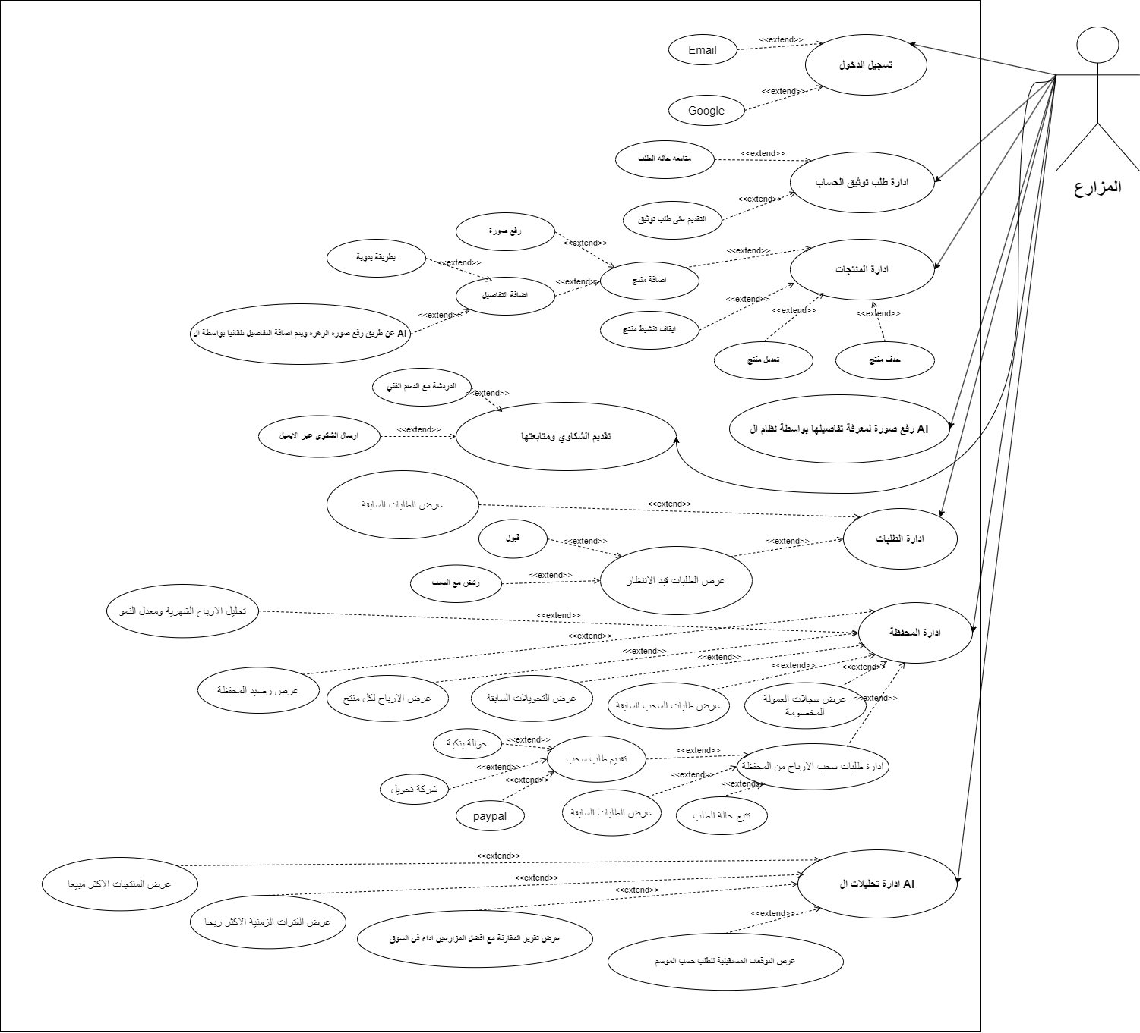

Farm use cases Figure 3.5

Use case number | Req-27
Use case | Log in via email
Brief description | The farmer enters his email and password and then logs in
The actors | Farmer
Previous conditions | The user enters the system
Subsequent terms | Log in to the account successfully
Main flow | 1-The farmer enters the site  2-Click on Log In  3-He enters his personal data  4-The system verifies the entered data  5-The system redirects the user to his own page
Alternative flows | If the user does not enter the data correctly, the system sends an error message to correct the error

Login process table Table 3.30

Use case number | Req-28
Use case | Product management
Brief description | The farmer manages the products in the system
The actors | Farmer
Previous conditions | The farmer must be previously logged into the system
Subsequent terms | The farmer can manage products in the system by modifying, deleting and adding
Main flow | 1-The farmer enters the site  2-Click on Manage Products  3-The system displays a list of available options  4-The farmer chooses the option he wants
Alternative flows | There is no
Product Management Process TableTable 3.31

Use case number | Req-29
Use case | Delete a product
Brief description | The farmer deletes a product in the system
The actors | Farmer
Previous conditions | The farmer must be previously logged into the system  The farmer must have previously added a product
Subsequent terms | The farmer can delete products from the system
Main flow | 1-The farmer enters the site  2-Click on Manage Products  3-The system displays a list of available options  4-The farmer selects the product he wants to delete and clicks Delete  5-The system displays a message that the deletion operation was successful
Alternative flows | There is no
Product deletion process table 3.32 Table

Use case number | Req-30
Use case | Edit a product
Brief description | The farmer modifies a product in the system
The actors | Farmer
Previous conditions | The farmer must be previously logged into the system  The farmer must have previously added a product
Subsequent terms | The farmer can modify product data from the system
Main flow | 1-The farmer enters the site  2-Click on Manage Products  3-The system displays a list of available options  4-The farmer selects the product whose data he wants to modify, writes the data, and clicks Edit  5-The system displays a message that the modification process was successful
Alternative flows | There is no
Product modification process table 3.33 Table

Use case number | Req-31
Use case | Deactivate a product
Brief description | The farmer deactivates a product in the system
The actors | Farmer
Previous conditions | The farmer must be previously logged into the system  The farmer must have previously added a product
Subsequent terms | The farmer can deactivate a product from the system
Main flow | 1-The farmer enters the site  2-Click on Manage Products  3-The system displays a list of available options  4-The farmer selects the product he wants to deactivate and clicks on it  5-The system displays a message that the deactivation process was successful
Alternative flows | There is no
Product deactivation process table34 Table3.

Use case number | Req-32
Use case | Add a product
Brief description | The farmer adds a product into the system
The actors | Farmer
Previous conditions | The farmer must be previously logged into the system
Subsequent terms | The farmer can add a product to the system
Main flow | 1-The farmer enters the site  2-Click on Manage Products  3-The system displays a list of available options  4-The farmer chooses to add a product, writes the details, adds pictures and price, and clicks Add  5-The system displays a message that the addition process was successful
Alternative flows | There is no
Exceptional flows | There is no
Table of adding a product process 3. 35 Table

Use case number | Req-33
Use case | Order management
Brief description | The farmer manages the orders in the system
The actors | Farmer
Previous conditions | The farmer must be previously logged into the system
Subsequent terms | The farmer can manage requests from offer, acceptance and rejection
Main flow | 1-The farmer enters the site  2-Click on Manage Requests  3-The system displays a list of available options  4-The farmer chooses the option he wants
Alternative flows | There is no
Exceptional flows | There is no
Order management process table 3.36 Table

Use case number | Req-34
Use case | View orders
Brief description | The farmer displays the orders (pending - finished - ongoing)
The actors | Farmer
Previous conditions | The farmer must be previously logged into the system
Subsequent terms | The farmer can view orders (pending - finished - ongoing)
Main flow | 1-The farmer enters the site  2-Click on Manage Requests  3-The system displays a list of available options  4-The farmer chooses to view orders  5-The system shows a list of completed, ongoing, and pending orders in the system
Alternative flows | There is no
Exceptional flows | There is no
Order presentation process table 3.37 Table

Use case number | Req-35
Use case | Accept the request
Brief description | The farmer accepts orders submitted by customers
The actors | Farmer
Previous conditions | The farmer must be previously logged into the system  The customer must have previously added an order
Subsequent terms | The farmer can view and accept requests
Main flow | 1-The farmer enters the site  2-Click on Manage Requests  3-The system displays a list of available options  4-The farmer chooses to view the submitted requests  5-The system displays a list of pending requests for the farmer to approve one of them and click Accept  6-The system displays a message about the success of the application acceptance process
Alternative flows | There is no
Application acceptance process table Table 3.38

Use case number | Req-36
Use case | Request rejected
Brief description | Farmer rejects requests (pending)
The actors | Farmer
Previous conditions | The farmer must be previously logged into the system  The customer must have previously added an order
Subsequent terms | The farmer can view (pending) requests and reject them
Main flow | 1-The farmer enters the site  2-Click on Manage Requests  3-The system displays a list of available options  4-The farmer chooses to view the submitted requests  5-The system displays a list of pending requests for the farmer to reject one of them and click Reject  6-The system displays a message that the request was rejected successfully
Alternative flows | There is no
Table 3.39 Request Rejection Process Table

Use case number | Req-37
Use case | Portfolio management
Brief description | The farmer manages his own portfolio
The actors | Farmer
Previous conditions | The farmer must be previously logged into the system
Subsequent terms | The farmer can view profits and balance and submit a request to withdraw profits
Main flow | 1-The farmer enters the site  2-Click on Manage Portfolio  3-The system displays a list of available options  4-The farmer chooses the option he wants
Alternative flows | There is no
Portfolio Management Process Table 3.40 Table

12 - Activity diagrams

Activity chart for login
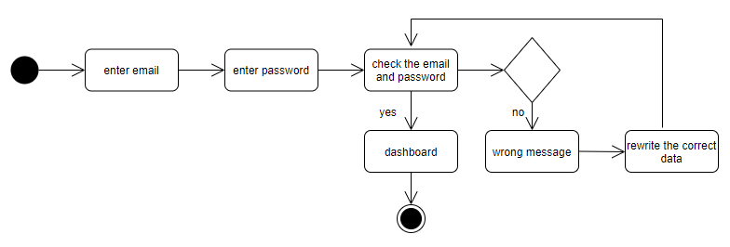
Figure 3.6 login

Order management Figure 3.7

Product Management3.8 Figure

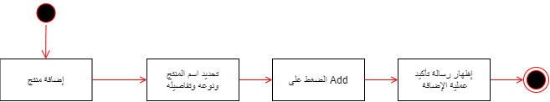

Adding a product 3.9 Figure

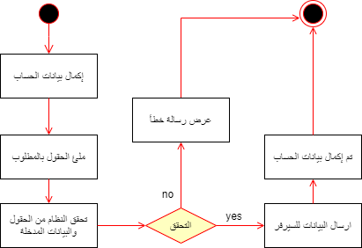

Complete account information 3.10 Figure

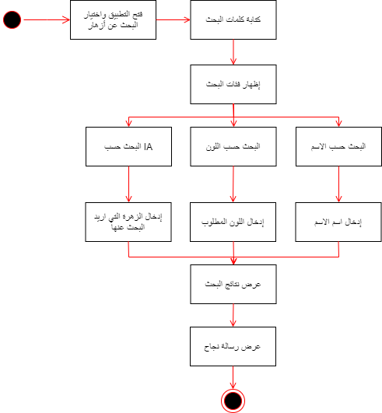

Searching for flowers 3.11 Figure
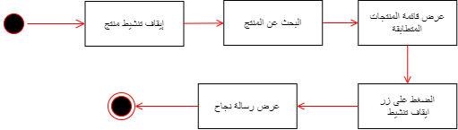

Deactivate an account 3.12 Figure

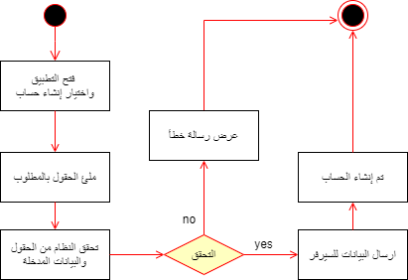

Create an account3.13Figure

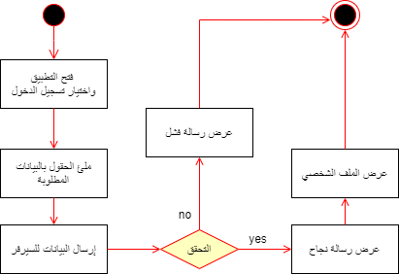

Farmer login 3.14 Figure

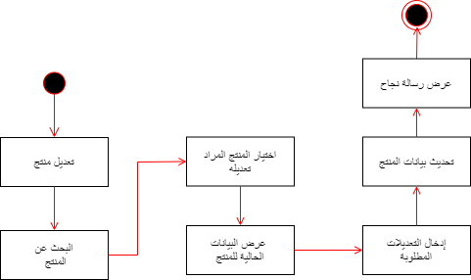

Modifying a product 3.15 Figure
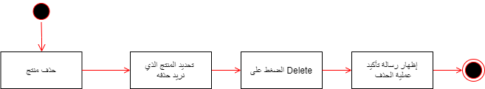

Deleting a product 3.16 Figure

Figure 3.17 Request rejected

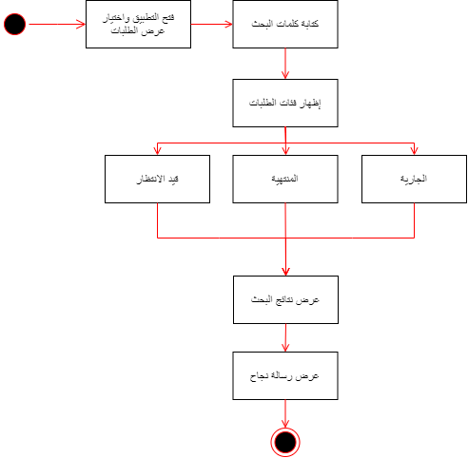

View orders3.18Figure

Ac ceptance of application 3.19 Figure

13- Sequence diagram
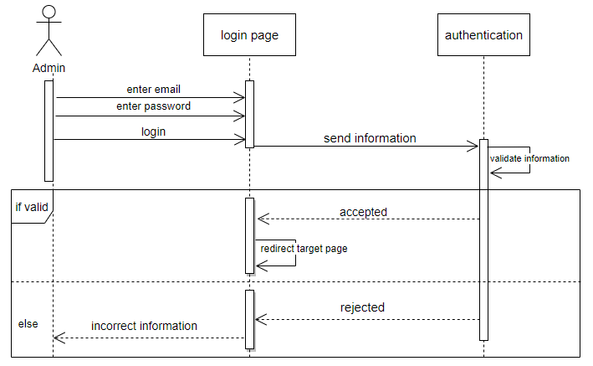

Figure 3.20 login

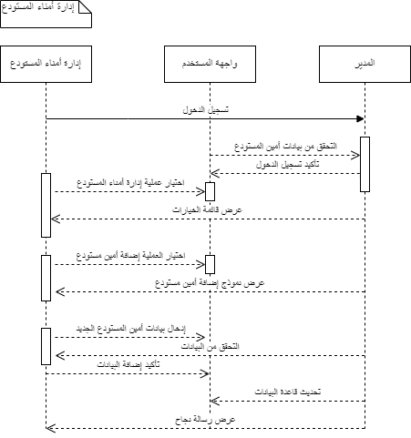

Farmer management 3.21 Figure

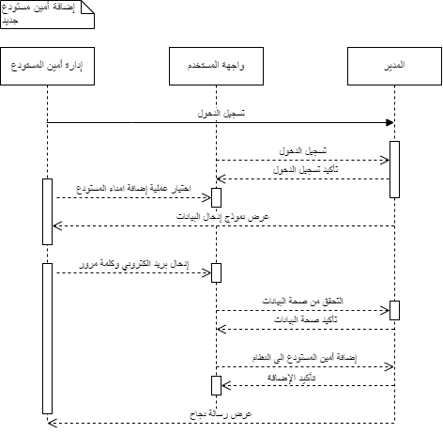

Adding farms 3.21 Figure

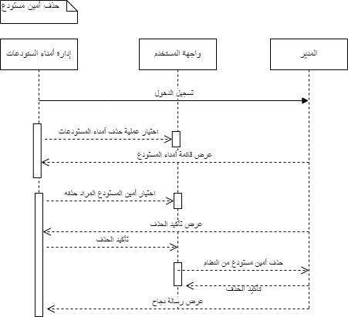
Delete farms Figure 3.22

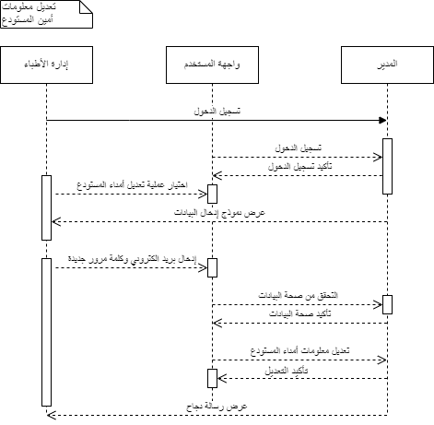
Modifying farmer data 3.23 Figure

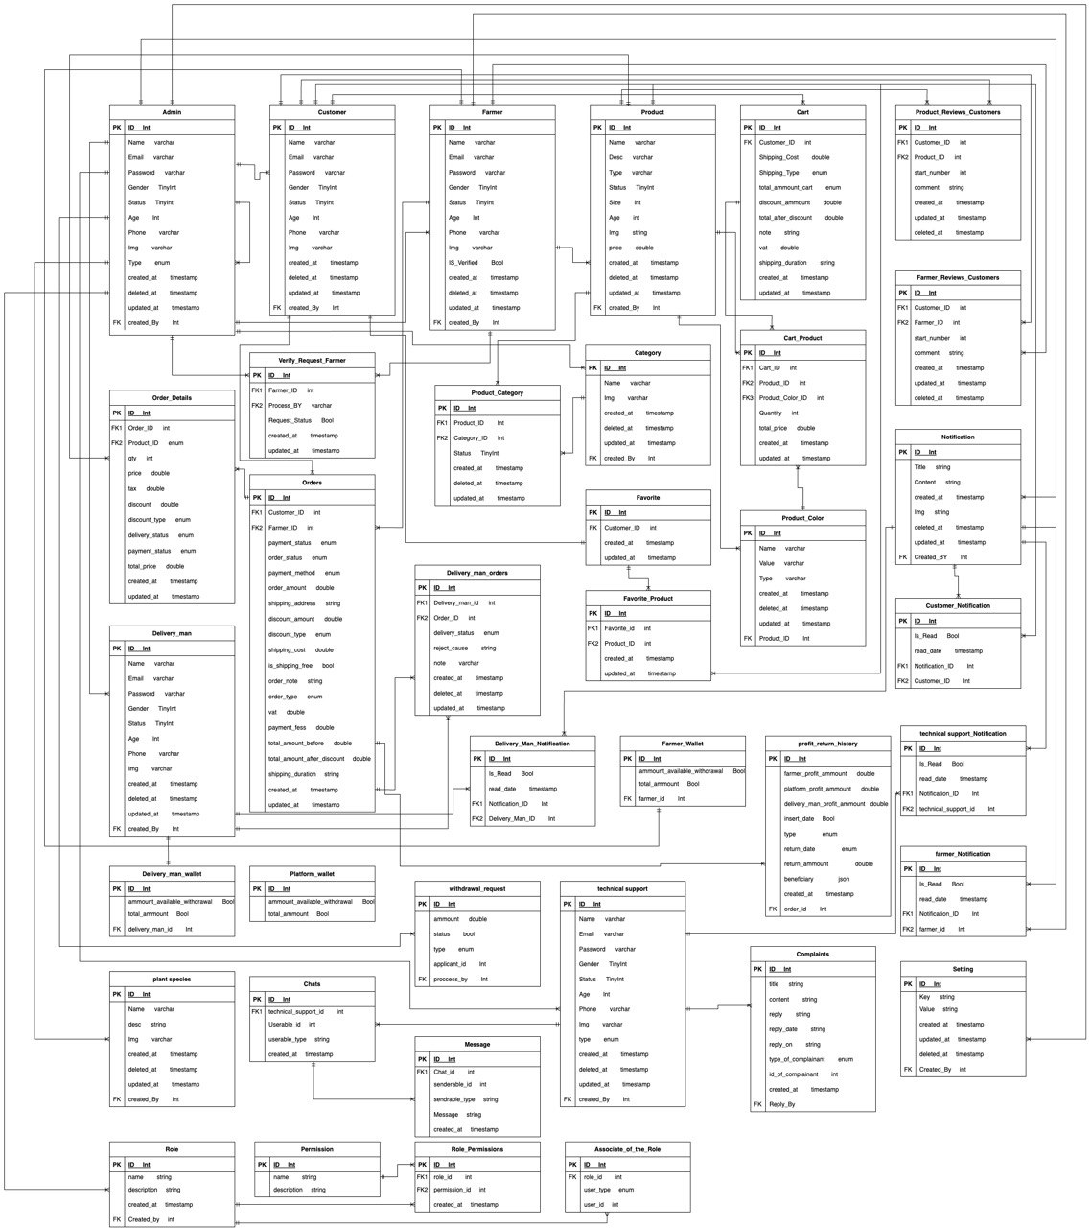
14- ER Diagram

Figure 3.24 ERD

15- List of preliminary tests:

Test case number | Test case type | Test case name | Test case description | Expected income | Expected output | Test result
Test-01.1 | Black box testing | Login test | Log in to the system with an existing account | (Username-Password) are correct | Login success | Successful
Test-01.2 | Black box testing | Wrong password test | Log in to the system by entering the wrong password | (wrong password) | Error message stating the password is incorrect | Successful
Test-03.1 | Black box testing | Add an administrator | Enter information about an administrator | User data (name - age - address....) | Addition success message | Successful
Test-03.2 | Black box testing | Add an administrator | Enter information about an administrator | User data (name - age - address....) is an empty field | Error Message No blank field allowed | Successful
Test-04 | Black box testing | Delete administrator | Possibility to delete an administrator | Press the delete button | Delete the administrator from the administrators list | Successful
Test-05 | Black box testing | Responsible edit | Possibility to modify administrator information | New user data (name - age - address....) | A message indicating the success of the modification process | Successful
Test-06 | Black box testing | Modify administrator permissions | Possibility to modify administrator permissions | New amended permissions data | A message indicating the success of the modification process | Successful
Test-07.1 | Black box testing | Farmers management | Farmer data management | Farmer data management | There is no | Successful
Test-08 | Black box testing | Delete farmers | Possibility of deleting farmers | Press the delete button | Delete a farmer from the farmer list | Successful
Test-09 | Black box testing | Modify farmers | Possibility of modifying farm information | New user data (name - age - address....) | A message indicating the success of the modification process | Successful
Test-10 | Black box testing | Add farmers | Enter information about the farms | User data (name - age - address....) is an empty field | Error Message No blank field allowed | Successful
Test-11 | Black box testing | Farmers show | The administrator displays the farmers in the system | Press the display button | A list of farmers appears | Successful
Test-12 | Black box testing | Deactivate farms | Ability for the administrator to deactivate farms | Press the deactivate button | A message indicating the success of the deactivation process | Successful
Test-13 | Black box testing | Customer management | Customer data management | Customer data management | There is no | Successful
Test-14 | Black box testing | Customer show | The administrator displays the clients in the system | Press the display button | A list of clients appears | Successful
Test-15 | Black box testing | Add a client | Enter information about the customer | User data (name - age - address....) is an empty field | Error Message No blank field allowed | Successful
Test-16 | Black box testing | Delete a client | Possibility to delete a client | Press the delete button | Delete a customer from the customer list | Successful
Test-17 | Black box testing | Modify customer data | Possibility to modify customer information | New user data (name - age - address....) | A message indicating the success of the modification process | Successful
Test-18 | Black box testing | Deactivate a client | The administrator's ability to deactivate a client | Press the deactivate button | A message indicating the success of the deactivation process | Successful
Test-19 | Black box testing | Manage roles and powers | Managing roles and powers | Click on the View Roles and Powers button | There is no | Successful
Test-20 | Black box testing | Show roles | The administrator displays the roles in the system | Press the display button | A list of roles appears | Successful
Test-21 | Black box testing | View permissions | The administrator displays the permissions in the system | Press the display button | A list of permissions appears | Successful
Test-22 | Black box testing | Add a role | Possibility of adding roles in the system | Enter the role information and click Add | Add the role to the database | Successful
Test-23 | Black box testing | Delete role | Possibility of deleting roles in the system | Click on the role you want to delete | Deletion success message | Successful

Table for the list of preliminary tests 3.41 Table

16- Develop a requirements traceability matrix:

It is a tool used in detailed project analysis to track and link requirements to other elements in the system such as components, design, tests, and deliverables. The matrix aims to ensure that each requirement is properly met and tracked over the various development stages.

Test Cases | Coding | System Design | Analysis | Use Case | Req_id
Test_01 | Code1 | AD_1 | SRS_1 | Login | Req-01
Test_02 | Code2 | AD_2 | SRS_2 | Responsible management | Req-02
Test_03 | Code3 | AD_3 | SRS_3 | Add an administrator | Req-03
Test_04 | Code4 | AD_4 | SRS_4 | Delete administrator | Req-04
Test_05 | Code5 | AD_5 | SRS_5 | Modify permissions | Req-05
Test_06 | Code6 | AD_6 | SRS_6 | Farmers management | Req-06
Test_07 | Code7 | AD_7 | SRS_7 | Add farmers | Req-07
Test_08 | Code8 | AD_8 | SRS_8 | Delete farmers | Req-08
Test_09 | Code9 | AD_9 | SRS_9 | Modify farmers | Req-09
Test_10 | Code10 | AD_10 | SRS_10 | Farmers show | Req-10
Test_11 | Code11 | AD_11 | SRS_11 | Farmers show i | Req-11
Test_12 | Code12 | AD_12 | SRS_12 | Deactivate | Req-12
Test_13 | Code13 | AD_13 | SRS_13 | Client management | Req-13
Test_14 | Code14 | AD_14 | SRS_14 | Client presentation | Req-14
Test_15 | Code15 | AD_15 | SRS_15 | Add a client | Req-15
Test_16 | Code16 | AD_16 | SRS_16 | Delete a client | Req-16
Test_17 | Code17 | AD_17 | SRS_17 | Modify customer data | Req-17
Test_18 | Code18 | AD_18 | SRS_18 | Deactivate | Req-18
Test_19 | Code19 | AD_19 | SRS_19 | Manage roles and powers | Req-19
Test_20 | Code20 | AD_20 | SRS_20 | Show roles | Req-20
Test_21 | Code21 | AD_21 | SRS_21 | View and powers | Req-21
Test_22 | Code22 | AD_22 | SRS_22 | Add roles | Req-22
Test_23 | Code23 | AD_23 | SRS_23 | Delete roles | Req-23

Requirements traceability matrix Table 3.42

17-System architecture
System architecture refers to the overall structure and organization of components in a system. It aims to achieve objectives in an efficient and organized manner, taking into account compatibility, scalability, security, maintainability, and performance. In an e-learning system, it can include components such as database, user interface, content management system, and assessment tools.

MVC Architecture: It is an architectural style used in designing software applications. The pattern aims to divide the application into three main parts: Model, View, and Controller.
Model: represents the application's data and logic. The model handles retrieving and updating data and performing operations necessary for the business logic of the application. The model is separated from view and control, allowing it to be reused and tested independently.
- View: displays data to the user and deals with the user interface. Presentation includes the graphic or textual design of the user interface and the presentation of data retrieved from the form. The display aims to present information in a visual and interactive way to the user.
Controller: Controls the coordination of interaction between the view and the model. It receives user signals and determines appropriate actions to deal with them, such as retrieving or updating the required data from the form. The control acts as an intermediary between the view and the model and controls the flow of data and events between them.

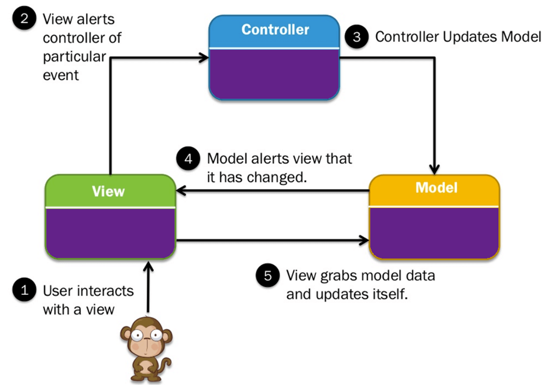
Using MVC, separation of concerns and improved reuse and testing of applications are achieved. It allows developers to work independently on each part of the application and provide efficient maintenance and development.
MVC Figure 3.25

Chapter Four
Design study of the proposed system

Chapter Four - Design study of the proposed system

- Introduction:

The design and implementation phases in software engineering aim to transform the requirements and specifications collected in the analysis phase into a detailed technical design for the proposed software system. The design phase and implementation phase include many activities and tasks that focus on defining the structure and organization of the system and determining how the requirements will be implemented.

Some of the main activities involved in the design and implementation phases of software engineering:

1. Determine the system structure: The system structure is determined and divided into subcomponents and interconnected units. How these components interact with each other and the relationships and communication between them are defined.

2. Interface design: The user interface is designed to interact with the software system. This includes identifying interface elements and components and organizing them logically and aesthetically.

3. Defining data and structures: The data that will be processed and stored in the system is determined, as well as the graphic structures used, such as databases and files.

4. Defining algorithms and logic: The algorithms and logic required to achieve system functionality and implement requirements are identified. Functional requirements are converted into specific steps and procedures that can be programmed.

5. Identifying components and technologies: The software components, tools, and technologies that will be used to implement the system are identified. Appropriate technologies must be selected to achieve performance, durability and ease of maintenance.

- Class Diagram:

2-1 Class Diagram Description:

Class Diagram is a graphical representation technique for designing the structure and relationships of classes in a software system. It is used to describe the various elements in a system and their relationships, including classes, interfaces, operations, properties, and the links between them.

A Class Diagram consists of basic elements that include:

1. Classes: They represent the programming code used to implement certain functions in the system. Rows are represented by a rectangle containing the row name at the top and properties and operations at the bottom.

2. Relationships: It explains the links and connections between the different rows in the system. These include generalization, association, dependency, aggregation, and others.

3. Attributes: They represent the data associated with the row, such as variables and fields that hold values for the row.

4. Methods: Displays the functions and methods that can be implemented by the class.

Diagrams are used in the software design phase to illustrate the structure of the system and the relationships of the different classes. These drawings help in understanding and documenting the design and facilitate communication between different development teams and developers.

  - Class Diagram:

Class Diagram:

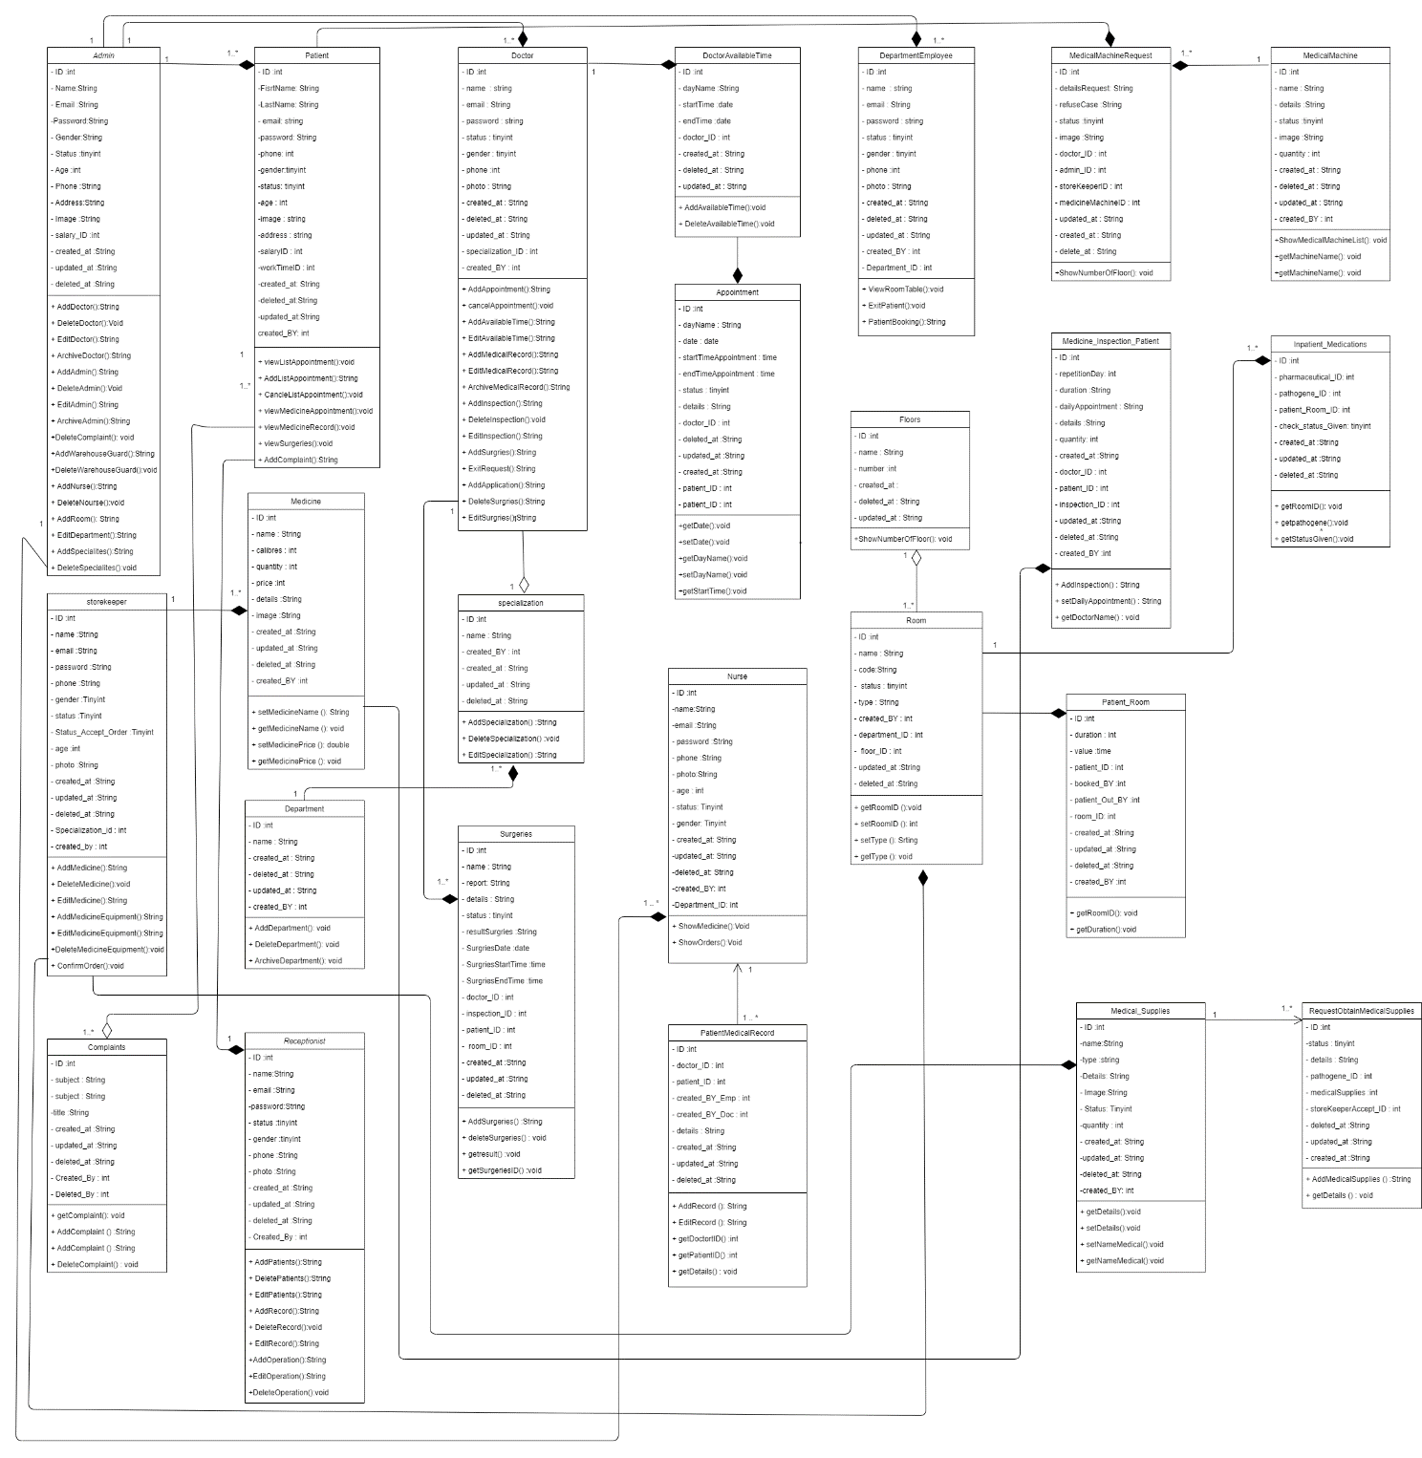

Class Diagram Figure 4.1

2-3 The basis that was adopted in the Class Diagram:
In constructing the class diagram, several foundations and principles are adopted to achieve good design and accurately represent the system structure.
Some of the principles adopted in constructing the row plan:

- The Independence Principle: It aims to achieve the independence of classes from each other, as classes must be designed so that they have specific functions and limited responsibilities, independent from the rest of the classes. This enhances the understanding and maintainability of the system and increases code reusability.

2. Clarity Principle: It relates to clarifying the relationships and connections between classes in a clear and understandable way. The diagram should be clear and legible so that readers can understand the relationships easily and without any confusion.

These previous foundations are general principles that must be taken into account while building a row plan.

3-Design models at the physical level:

To design an integrated electronic system for managing an integrated, integrated flower commerce platform that is advanced at the physical level, the model can be divided into several main components that include hardware, networks, security, storage, and energy as follows:

1. Peripherals
- User devices (computers, smartphones, tablets): used by system users and administration to access the system.

2. Servers and databases
- Central servers:
-Web servers: host the user interface and web applications.
- Application servers: manage the basic processes and functions of the system.
- Database servers: store user data, schedules, payments, and purchase data.

3. Safety elements
- Firewalls: to protect the network from external attacks.
- Intrusion Detection Systems (IDS): to monitor unusual activities.

4. Storage and backup components
- Storage devices:
- Hard disks (HDDs) and solid state disks (SSDs): for storing data.
- Network Storage Systems (NAS) and Direct Storage (DAS): for large storage solutions.

- Backup systems:
- Backup servers: to protect data from loss.
- Cloud storage: Back up data off-site.

5. Energy components
- Uninterruptible power supplies (UPS): to ensure continuity of service in the event of a power outage.
- Emergency Generators: Providing energy in long emergency situations.

6. Software components (in addition to the physical level, but essential for understanding the model as a whole)
- Electronic payment platforms: to process payments and accounts
- Smartphone applications: to access services and information.

This model provides a general overview of how to design an integrated physical system to manage an integrated flower e-commerce platform, with an emphasis on interconnecting the various components to achieve effective management and provide an excellent customer experience.

Chapter Five
Practical application

Chapter Five - Practical Application

-Introduction
In this chapter, we will talk about the tools we used to build the system, and we will also present the main interfaces of the system
- Tools used:

1.draw.io: is a free, open source, cross-platform drawing software. Its interface can be used to create diagrams such as flowcharts, wireframes, UML diagrams, organizational charts, and network diagrams.

2.VS Code: It is a script editor from Microsoft. The editor is open source and works on Windows, Mac OS, and Linux operating systems. The editor is based on the Electron environment, and was launched by Microsoft in April 2015.

3. PHP programming language: A high-level text programming language designed primarily to be used for developing and programming web applications. It can also be used to produce stand-alone programs that are not related to the web only. [12] [13]

4. MySQL databases: A relational database management system based on the SQL language. It is an open source product whose source code is published under the GNU General Public License in addition to some proprietary agreements

Laravel.5: It is an open source framework for developing web applications using the PHP language. Laravel provides a set of tools and features for faster and more efficient application development, such as routing, ORM (Eloquent), scheduling tasks, and unit testing, making it one of the most popular frameworks in the PHP community.

6.

2-Techniques used

- HTML: It is a markup language used to create and design pages and websites. This language is considered one of the oldest and most widely used languages ​​in designing web pages.
HTML is the structure of a web page and gives the Internet browser a description of how to view its contents. It tells him that this is a headline, this is a paragraph, and much more.
2.CSS: It is a formatting language for web pages that is concerned with the form and design of websites. It was specifically designed to isolate formatting (colors - fonts - buttons...) from the content of the written document) in the HTML language (this applies to the colors, fonts, images, and backgrounds that are used on pages, with complete flexibility and ease.
This technology is concerned with the overall appearance of website pages, including colors, images, etc.

3.JavaScript: It is a high-level programming language that is mainly used in web browsers to create more interactive pages. It is currently being developed by Netsib and Mozial. The JS language was intended for amateur and non-professional programmers, but interest in it increased and attracted the attention of professional programmers after adding new technologies, such as the spread of the AJAC technology, which led to faster interaction between the server and the client. JavaScript is used to create interactive web pages, and to provide web applications including games; It is used by most websites, and is supported by almost all browsers without the need for external add-ons.

PHP.4: It is a scripting language designed primarily to be used for developing and programming web applications. It can also be used to produce stand-alone programs that are only related to the web.
PHP is an open source language developed by a team of volunteers under the PHP license. It supports object-oriented programming and its structural structure is very similar to the C language. In addition, it works on multiple operating systems such as Linux and Windows.

5.Laravel: Laravel is an open source programming platform for Internet applications or a framework for developing web applications written in the PHP language. Taylor Otwell launched Laravel in February 2012

Bootstrap.6: It is a set of open source tools for designing website interfaces, developed by Twitter. It was created to help designers and developers build amazing products quickly and effectively. Its goal is to provide a vast, flexible, well-documented library of “reusable” designs built using HTML, CSS, and JAVASCRIPT for developers to use and create with.

3-Mini models of the implementation process

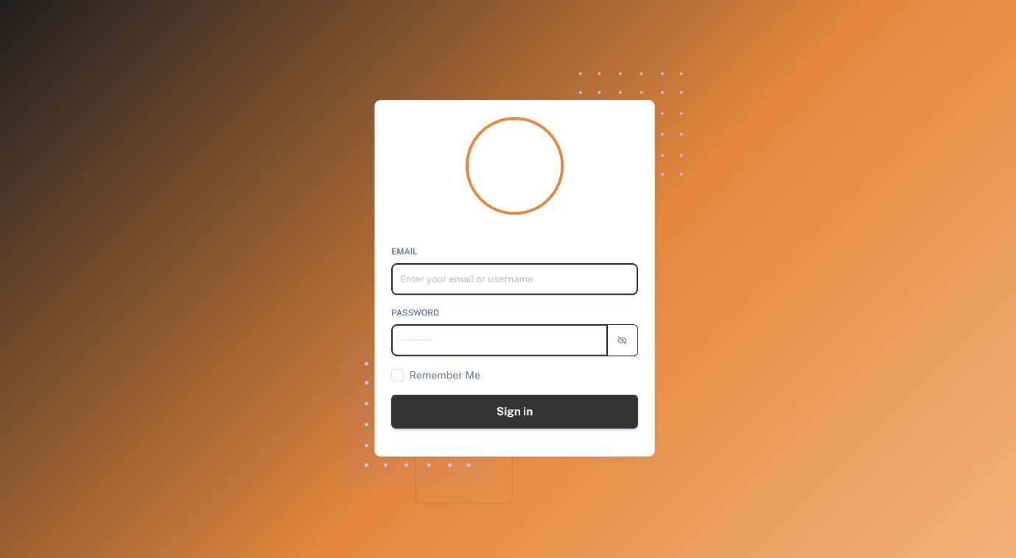

Login page 5.1 Figure



Website home page 2 .5 Figure

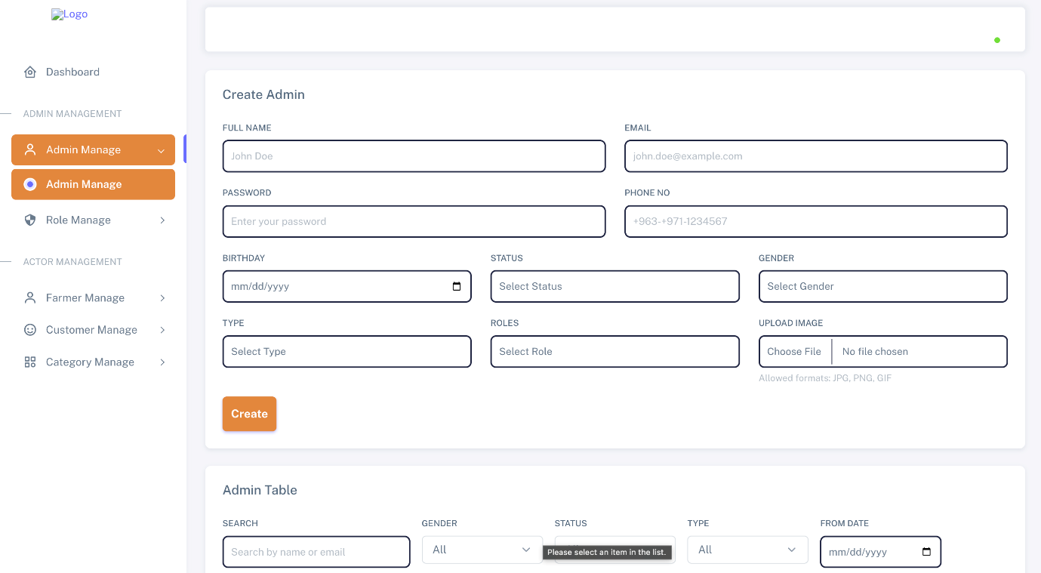

Adding an administratorFigure 5.3

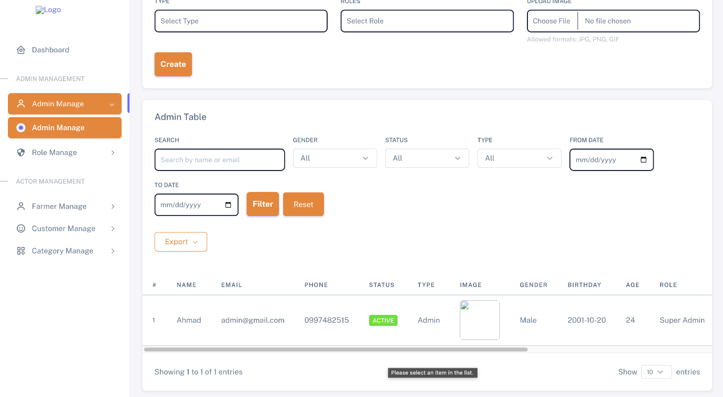

Figure 5.4 Administrators table page

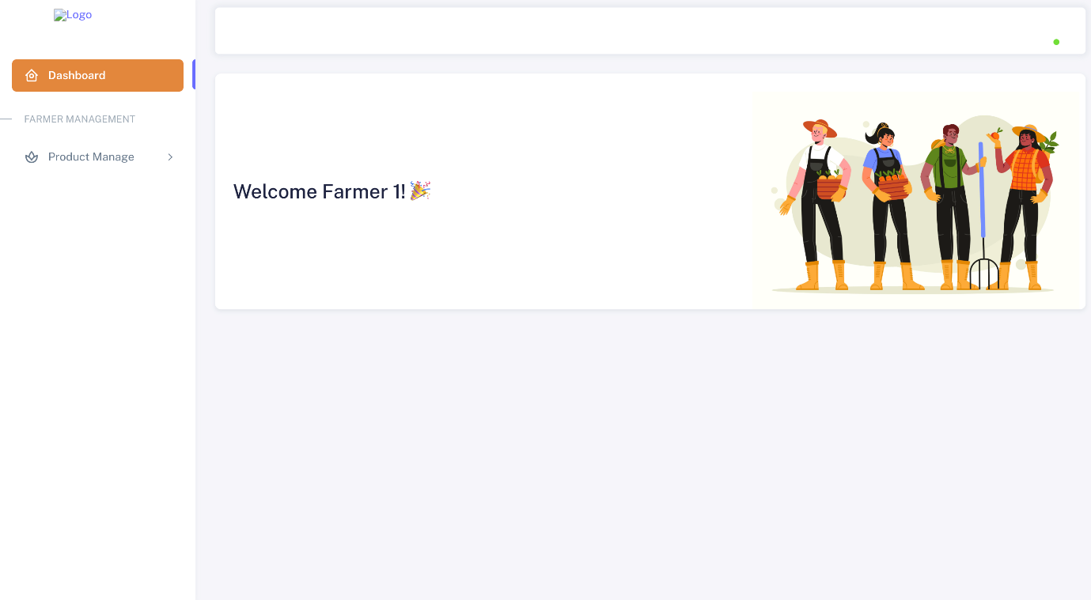
Farmer's home page 5.5 Figure

Chapter Six
Conclusions and future prospects

Chapter Six - Conclusions and future prospects

1-Introduction

Working in the field of software engineering requires continuous development and keeping pace with technical changes and renewed user needs, so no software system can be considered absolutely final or complete. The e-flower e-commerce platform presented in this project represents a strong and well-established core, capable of expansion and future development, whether in terms of adding new features, improving performance, or addressing cases that could not be implemented within the project time frame. Therefo
re, it can be said that the current platform forms a solid foundation upon which to build to meet the requirements of the growing e-flower market.

2-Future prospects
The development of the rose e-commerce platform opens the way for many future improvements that can increase the efficiency of the system, improve the user experience, and increase the competitiveness of the platform. The following are the most prominent proposed future prospects:
1. Artificial intelligence and user behavior analysis
- Using artificial intelligence techniques to analyze customer behavior and preferences in order to provide personalized suggestions for flowers and bouquets.
- Apply recommendation algorithms to display suitable products based on previous occasions or repeated purchases.
2. Smart inventory management
- Develop an intelligent inventory management system that predicts shortages or surplus of roses based on seasonal demand data.
- Reduce waste resulting from damaged flowers by accurately forecasting the quantities required.
3. Integration of electronic payment gateways
- Supporting more electronic payment methods such as digital wallets and mobile payment.
- Improve the security of payments using encryption and two-factor authentication technologies.
4. Smartphone applications
- Develop a custom application for smartphones (Android and iOS) to facilitate access to the platform and increase interaction with users.
- Send instant notifications of special offers, order confirmations, and delivery status.
5. Smart delivery and order tracking
- Integrating a real-time order tracking system to enable the user to know the exact status of his order.
- Cooperating with smart delivery services to improve the speed and accuracy of flower delivery.
6. Support custom events and orders
- Adding the feature of designing custom flower bouquets according to the client’s taste and the occasion (wedding, birthday, graduation, funeral).
- Support pre-scheduled orders for future dates.

References

  - https://www.shopify.com/
  - https://woocommerce.com/documentation/
  - https://www.uml.org/
  - https://www.php.net/
  - https://github.com/php/php-src
  - https://www.paypal.com/
  - https://stripe.com/
  - https://www.statista.com/
  - https://www.marketresearchfuture.com/
  - https://www.floristone.com/
  - https://www.teleflora.com/

